By: Jubayad Hassnat

Probability & Statistics Final Project Documentation

Table of Contents

Part 1: Datasets and Graphs 3

Code 3

Quadratic Graph 9

Outputs 9

Sine Graph 14

Outputs 14

Absolute Graph 18

Outputs 18

Part 2: Octave 23

Octave Tutorial & Learning 23

All Learning Sources 28

Octave Code & Outputs 29

Main.m 29

OriginalFormula.m 46

Salter.m 48

Smoother.m 49

DataHandler 49

What is Octave (1 Page Paper) 50

Part 3: JFree 51

Final Report 52

Abstract 52

Question 1 52

Answer 53

Question 2 54

Answer 54

Question 3 54

Answer 55

Question 4 55

Answer 55

Question 5 56

Answer 56

Question 6 56

Answer 57

Question 7 57

Answer 58

Question 8 58

Answer 58

Question 9 59

Answer 59

Question 10 60

Answer 60

Question 11 60

Answer 60

Question 12 61

Answer 62

Question 13 62

Answer 63

Dataset Citation 64

Stats Library 64

Code 64

Factorial 64

Poissan 64

Chebyshev 65

Uniform Distribution 65

Normal Distribution 65

# Part 1: Datasets and Graphs

## Code

#### Main.java

This is the output of my csv files filled with values of the original graph, the salted values, and the smoothed values. Each formula, quadratic, sine, and absolute has three sets. Each set has bounds from -10 to 10, -25 to 25, and -50 to 50 namely.

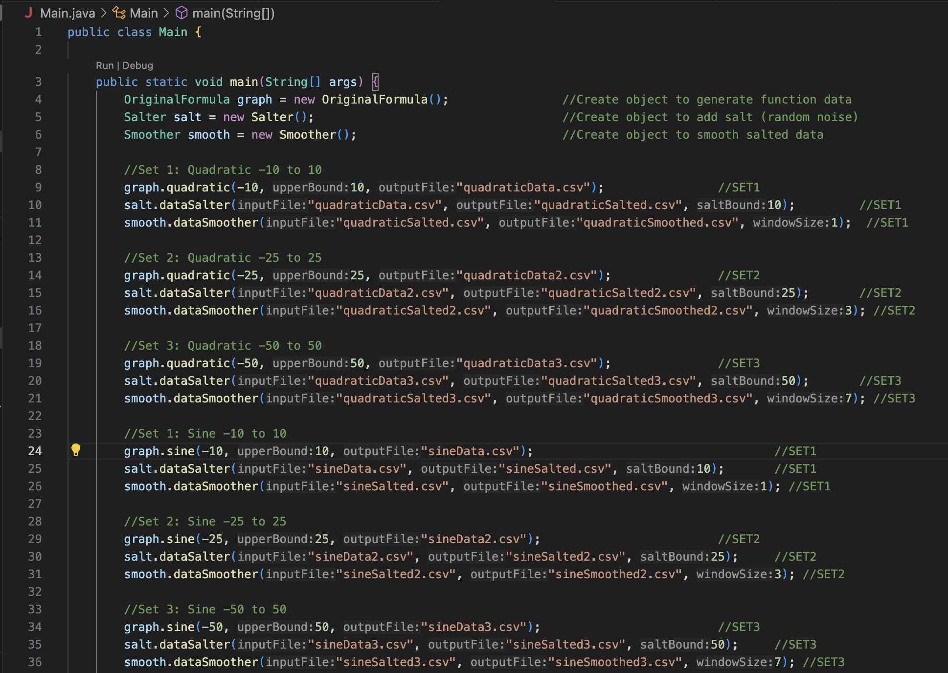

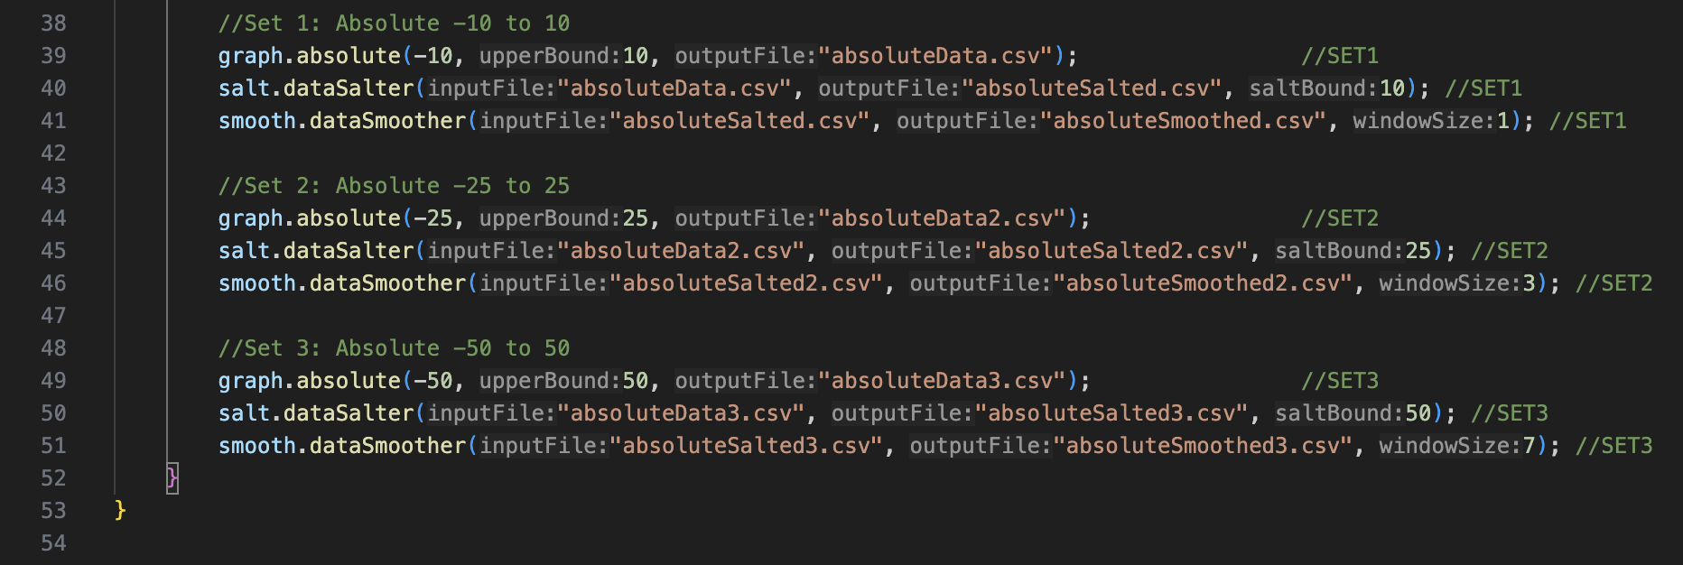

#### OriginalFormula.java

##### Quadratic

The quadratic class is made by having the parameters of lowerBound, upperBound, outputFile. This allows us to set the upper and lower bounds along with the output file. By having a designated output file, it allows for the program to write over the file rather than creating a new file on every run. The quadratic class loops from the lower bound to the upper bound. It uses the formula y $=x^{2}-4x+3$. The values of the points are added to the points array list and that array list gets saved to the outputFile by the DataHandler object. If it fails, it gives us an error and we are able to debug using that.

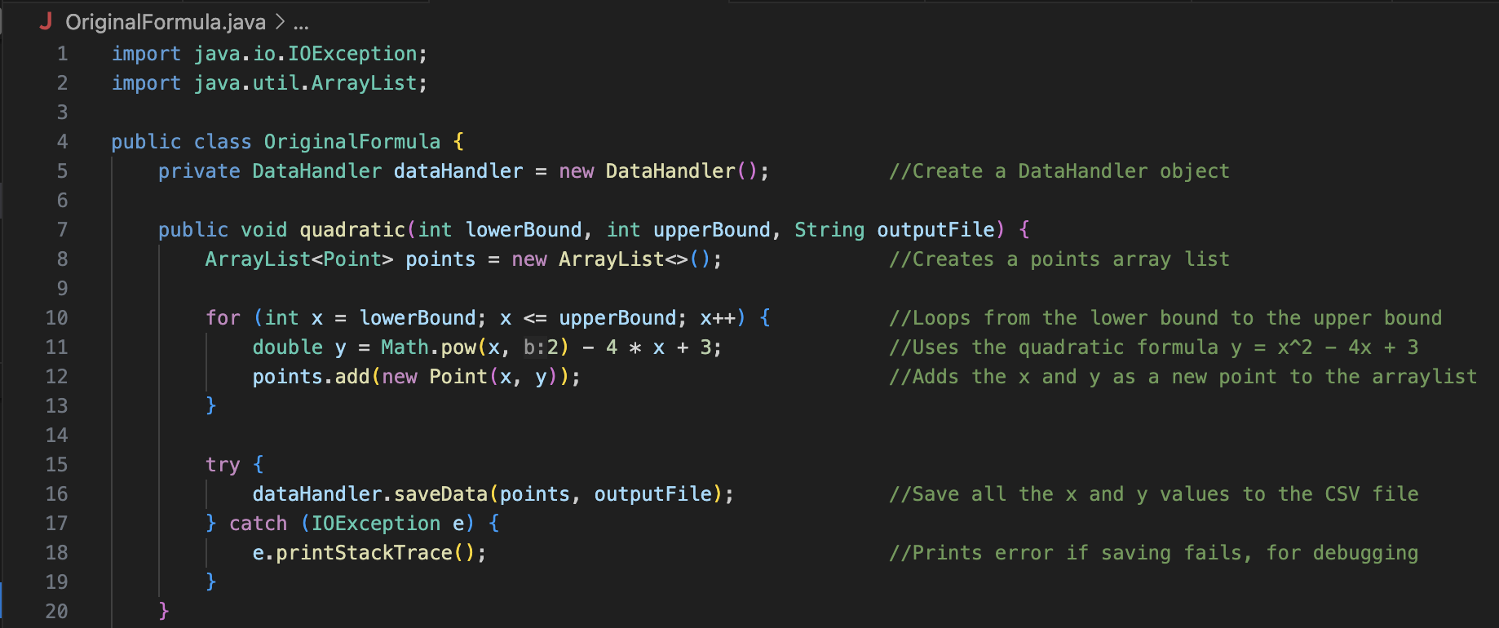

##### Sine

The sine class is made by having the parameters of lowerBound, upperBound, outputFile. The quadratic class loops from the lower bound to the upper bound. It uses the formula. The values of the points are added to the points array list and that array list gets saved to the outputFile by the DataHandler object. If it fails, it gives us an error and we are able to debug using that.

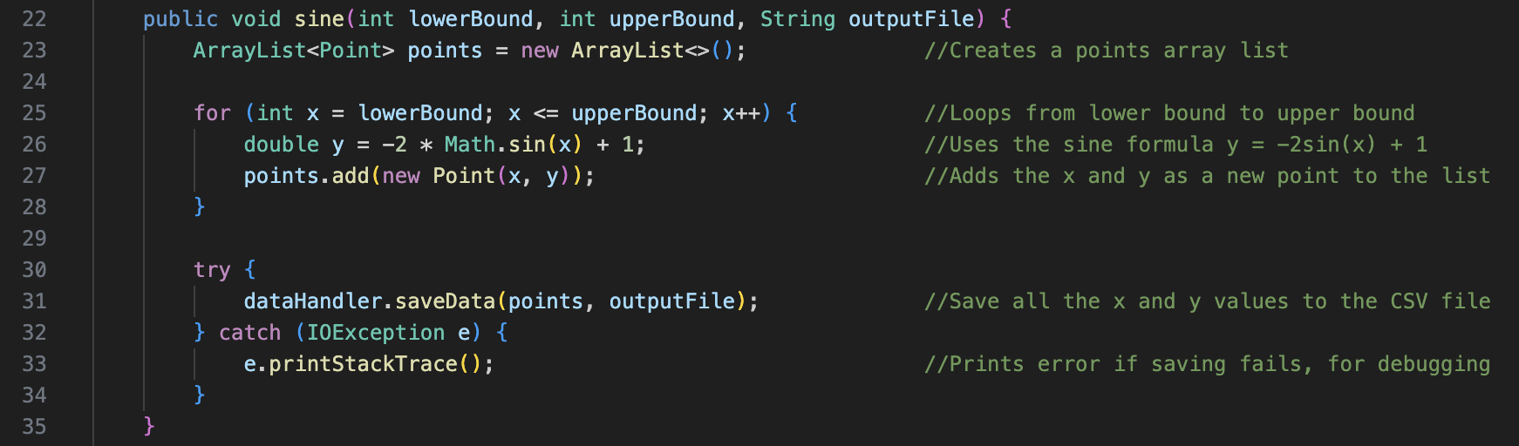

##### Absolute

The absolute class is made by having the parameters of lowerBound, upperBound, outputFile. The quadratic class loops from the lower bound to the upper bound. It uses the formula. The values of the points are added to the points array list and that array list gets saved to the outputFile by the DataHandler object. If it fails, it gives us an error and we are able to debug using that.

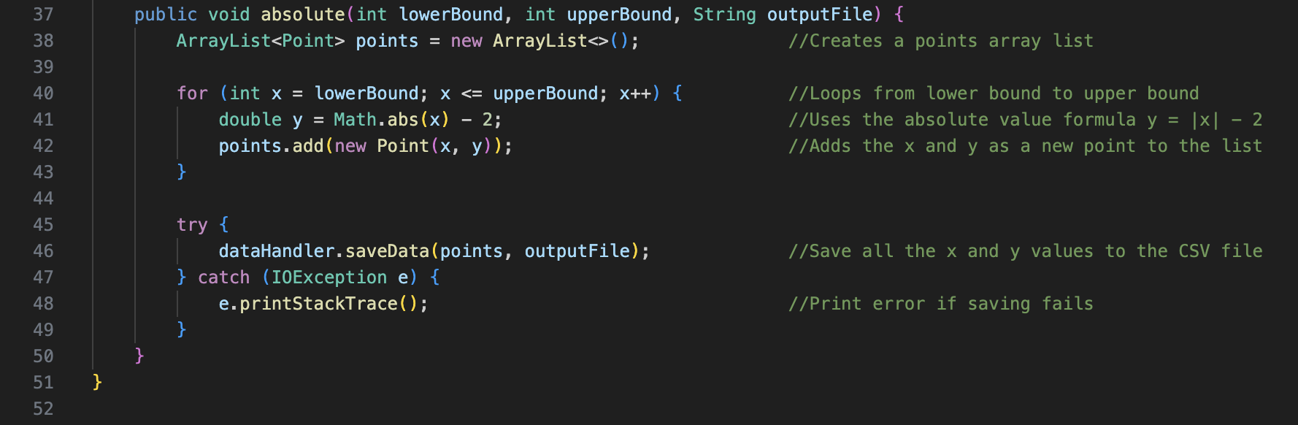

#### Salter.java

The Salter class reads the data of the inputFile that’s given to it through the parameter. After the data is read, it checks if the given salt range is greater than 1. If not, it returns and says for the user to change the salt range. If it goes through, it applies the salt algorithm, which is a random value that’s within the salting range and adds it to the y value. They add this new salted y value to the saltedPoints array, and this array is than written into a new csv file that’s handled by the DataHandler object. If it fails, it gives us an error and we are able to debug using that.

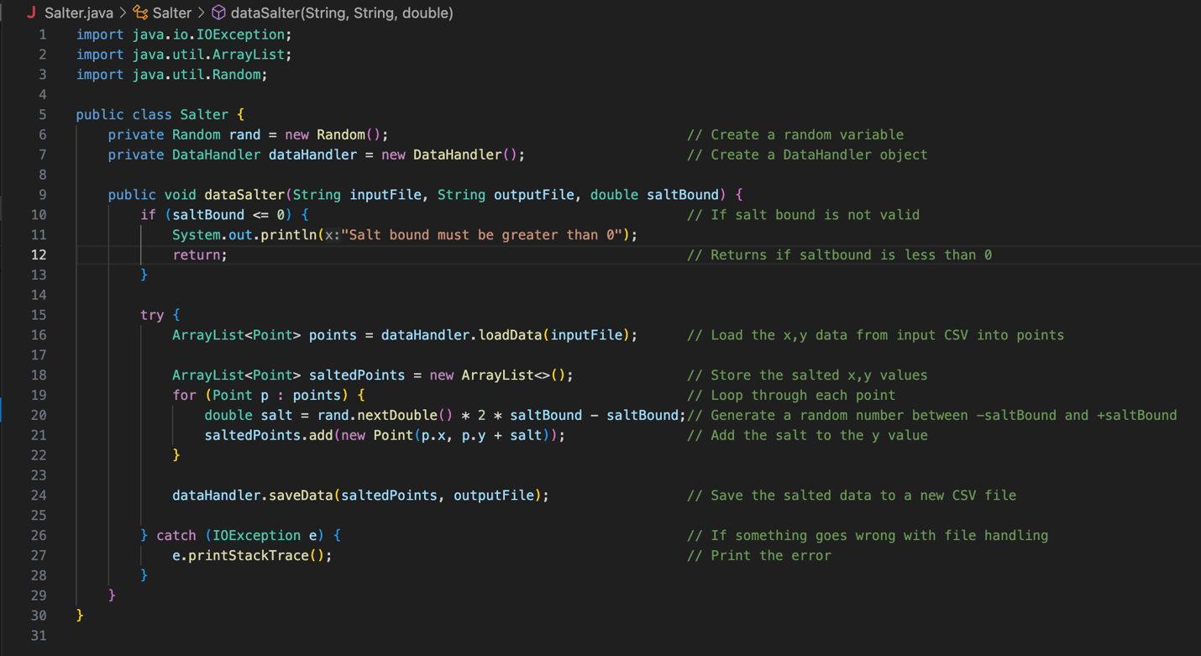

#### Smoother.java

The smoother class takes read’s the input file that’s given to it by the parameter. It than takes the y values from the file and applies the smoothing algorithm to it. The smoothing algorithm is finding both the start and ending values of the y values. From the given windowSize variable, it finds the average point by looping through from the start to the end values. This new value is then the new smoothed y value. This value is then written and saved into a csv file which is handled by the DataHandler object.

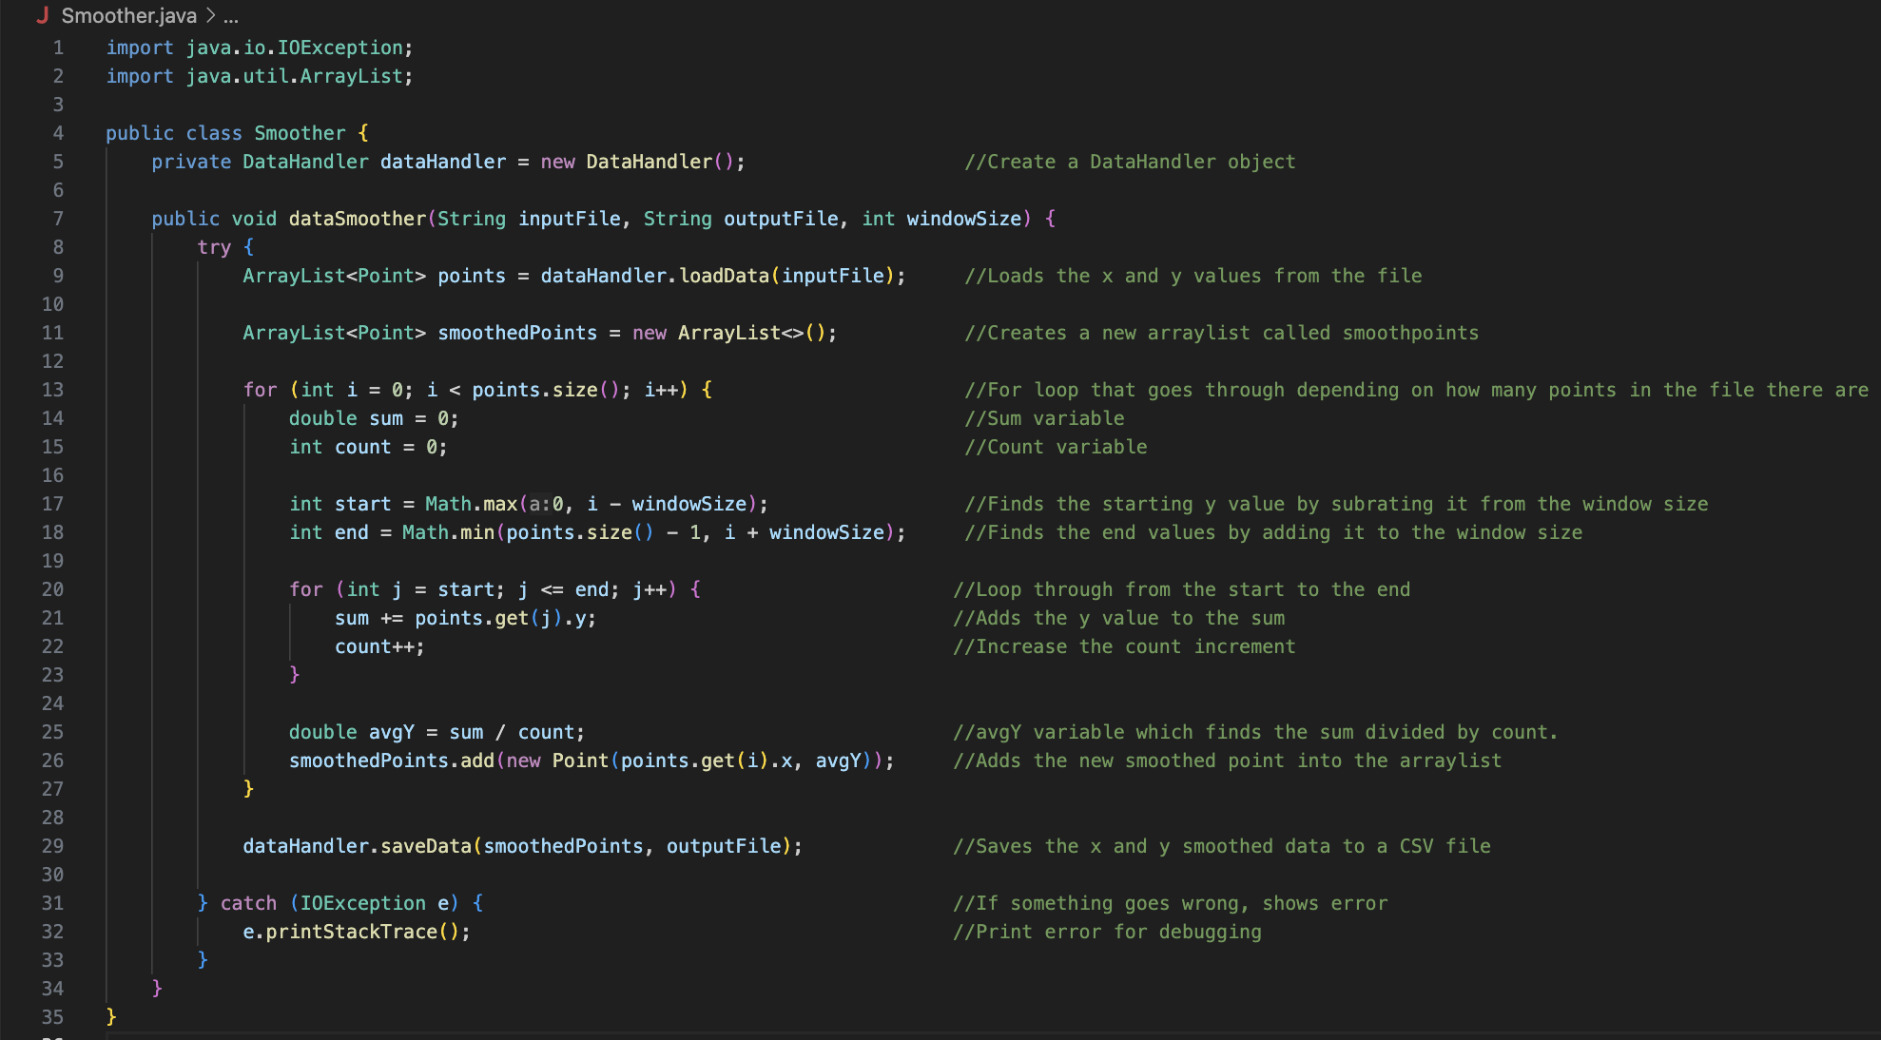

#### DataHandler.java

##### loadData.java

The loadData class creates an arraylist variable called data. It then tries to read the csv file. Once it reads the file, it skips the header, which just says “x, y” which is irrelevant to the class. It than makes the values given into it into a coordinate point, in the form of x,y. Then it transforms the x values given to it to a double and lets it be referenced as x. Same thing is done to the y value. Then both of them data values are stored into the file in the form of x,y.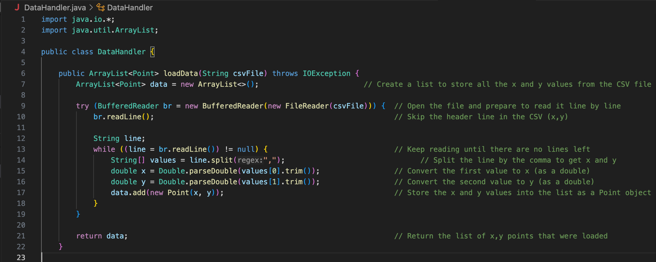

##### saveData.java

The saveData class writes data into a file. If the file exists already, then it writes on top of it. It writes the header of the csv file as x, y. It then loops through every point and writes the values into the file in the form of x, y. Once done, it prints a message saying this was successfully printed into this new file.

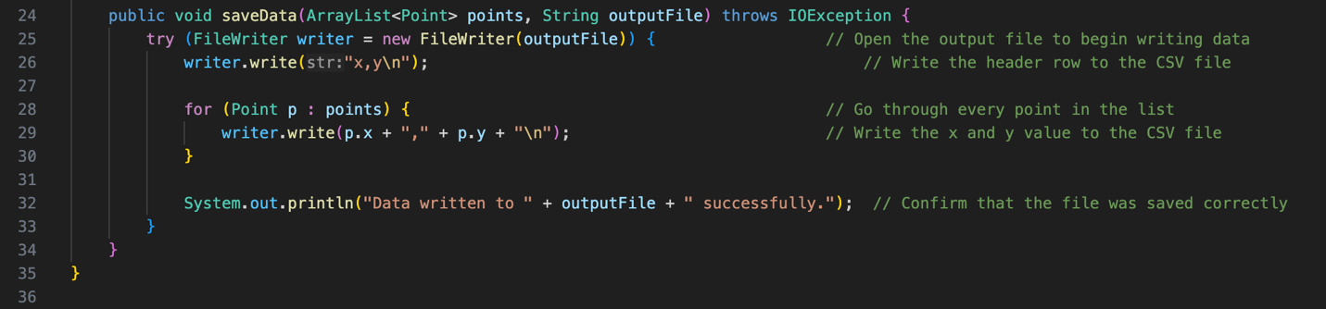

#### Points.java

The points class creates a class that has two double variables, x and y. These variables can be referenced and used by calling the point method.

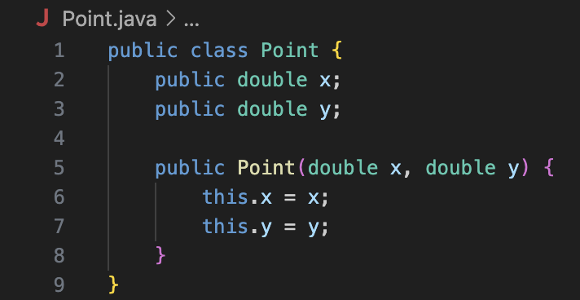

## Quadratic Graph

Formula Used: $y=x^{2}-4x+3$

### Outputs

#### Set 1:

Bounds: -10 to 10

Salt Range: -10 to 10

Smoother Window Size: 1

#### Set 2:

Bounds: -25 to 25

Salt Range: -25 to 25

Smoother Window Size: 3

#### Set 3:

Bounds: -25 to 25

Salt Range: -25 to 25

Smoother Window Size: 3

## Sine Graph

Formula Used: $y=-2\sin\left(x\right)+1$

### Outputs

#### Set 1:

Bounds: -10 to 10

Salt Range: -10 to 10

Smoother Window Size: 1

#### Set 2:

Bounds: -25 to 25

Salt Range: -25 to 25

Smoother Window Size: 3

#### Set 3:

Bounds: -25 to 25

Salt Range: -25 to 25

Smoother Window Size: 3

## Absolute Graph

Formula Used: $y=\left|x\right|-2$

### Outputs

#### Set 1:

Bounds: -10 to 10

Salt Range: -10 to 10

Smoother Window Size: 1

#### Set 2:

Bounds: -25 to 25

Salt Range: -25 to 25

Smoother Window Size: 3

#### Set 3:

Bounds: -25 to 25

Salt Range: -25 to 25

Smoother Window Size: 3

# Part 2: Octave

## Octave Tutorial & Learning

<https://www.youtube.com/watch?v=LhPZwdhutgU>

I started following the first source. I did something very simple and plotted the first 10 values of a sine function. I ran some very simple code and plotted it. I got this from running the following script in the Octave gui:

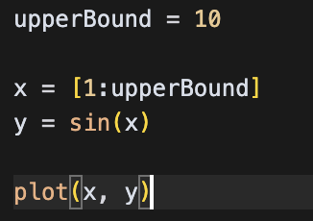

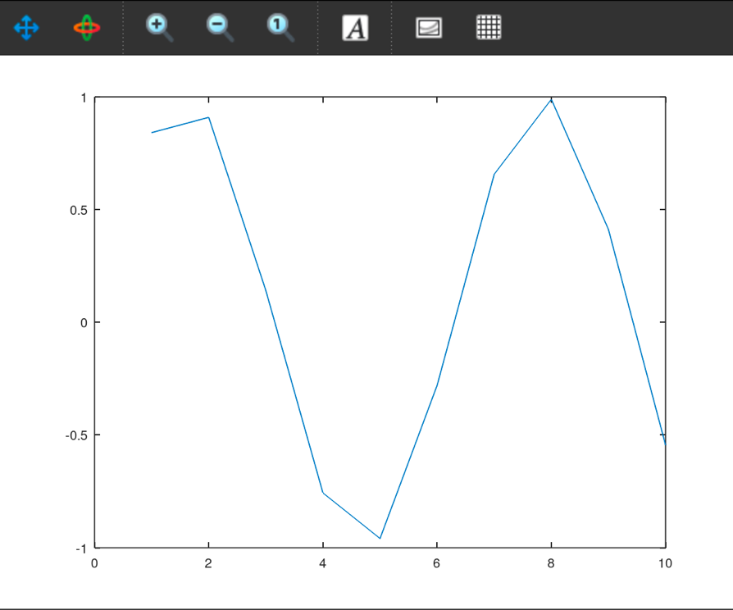

The code sets the upper bound variable equal to 10. X is the increments from the first value, which is 1, to the variable upper bound, which is 10. Y is equal to the sine of x. The resulted graph depicts exactly that as we can see that x starts at 1 and ends at 10. Y is the values of the sine function.

<https://www.youtube.com/watch?v=NtMOab_nhs0>

https://www.youtube.com/watch?v=WUxImdA7k8E

As I got more familiar with Octave and watching more videos, I started to learn about different ways to structure my code and how to ask for certain data to be printed out into graphs. I also learned about the “hold on” syntax which retains the data that was given and add more data on top of it. Below is my test code based on what I learned and saw from their test code:

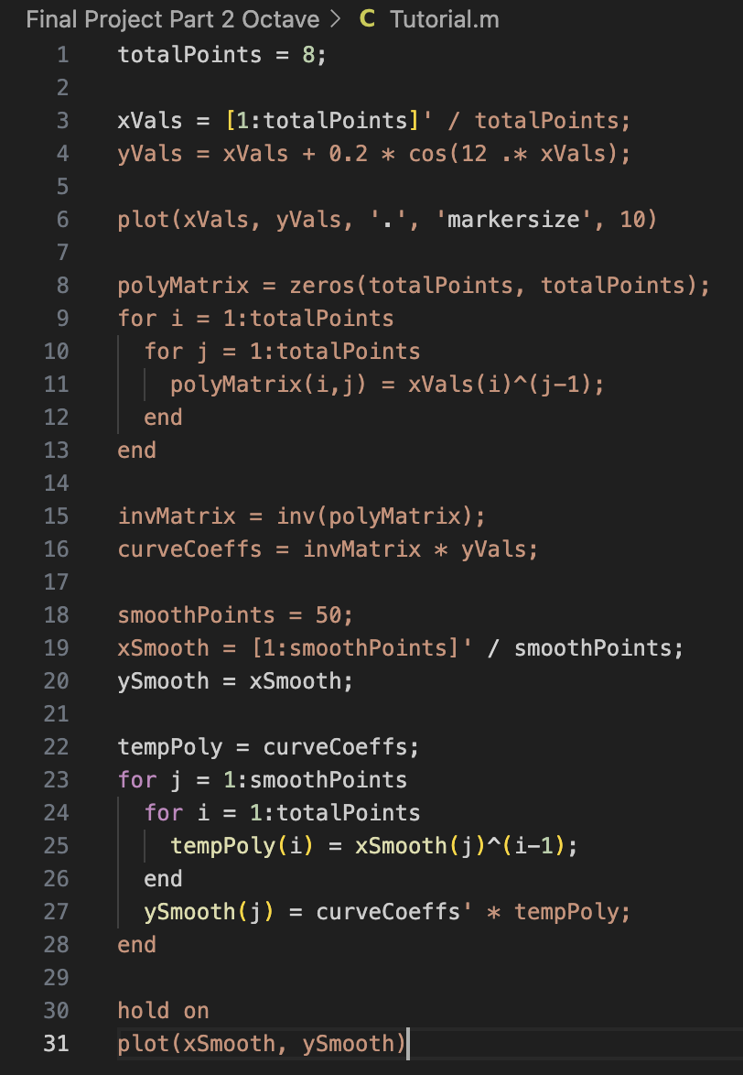

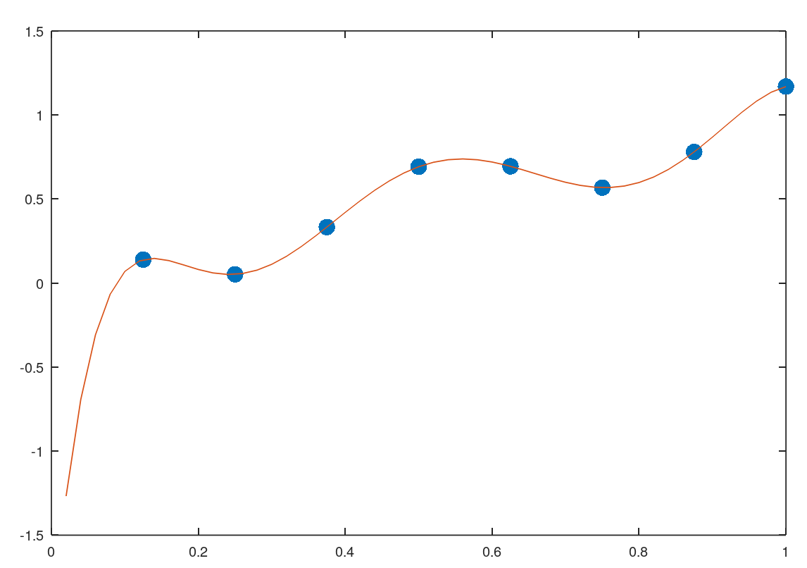

I took apart their code and tried to understand what each line does.

Line 1 sets the variable npoints equal to 8.

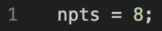

Line 3 creates a new variable x which equals to increments of 1 through 8 divided by 8. The “ ’ ”, or apostrophe, turns it into columns.



Line 4 creates a new variable y which creates a cosine function with extra values making it not look like a regular cosine wave.



Line 6 uses the plot function to plot the variables of x and y. The ‘ . ’ Changes the markers to become dots or periods. The ‘markersize’, 10 syntax makes the size of the markers bigger so that it’s easier to see.



Line 8 makes a new variable called S which filles a matrix filled with zeros to the length of 8, since npts is equal to 8.



The nested for loop from lines 9-13 fills the matrix that’s filled with zeros with values. It goes row by row.

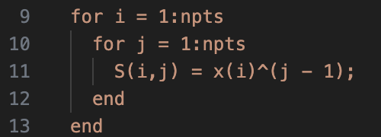

Line 15 creates a new variable called Sinv which uses the inverse function to find the inverse of the S variable matrix that’s filled.

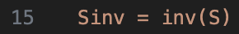

Line 16 creates a new variable called the c which multiples the values of the Sinv variable and the values of the y variable. This variable tells us what numbers to use to find the best curve.



Line 18 creates a new variable called np2 and sets that equal to 50. The purpose of this variable is to have more points in the graph, making our graph smoother.

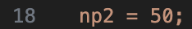

Lines19-20 creates new variables called x2 and y2. x2 is equal to the values of 1 to npt2, which is 50. The “ ‘ “, or the apostrophe turns it into columns and then the value is divided by np2, or 50. The variable y2 is equal to the values of x2

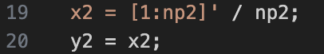

Line 21 creates a new variable fj which is equal to the values of c.



Line 22-27 is a nested for loop in which calculates the values of y2 using the formula. The first for loop runs from 1 to np2 which is 50. The second loop runs from 1 to npts which is 8.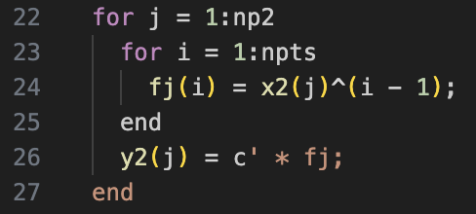

Line 29 uses the syntax “hold on” which keeps the values plotted from before.

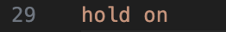

Line 30 plots the values of x2 and y2.

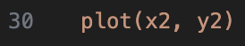

## All Learning Sources

1. <https://www.youtube.com/watch?v=LhPZwdhutgU> - basics

2. <https://www.youtube.com/watch?v=NtMOab_nhs0> - more in depth

3. <https://www.geeksforgeeks.org/octave-basics-of-plotting-data/> - basics

4. <https://bioweb.pasteur.fr/docs/modules/octave/3.8.2/octave/Formatted-Output.html#XREFsprintf> – title configurations for cleaner output

## Octave Code & Outputs

### Main.m

#### Set 1 Quadratic Code:

Lines 4-7 runs the first set of the quadratic function. It uses the bounds of -10 to 10, uses the salted range of 10, and the window size of 1.

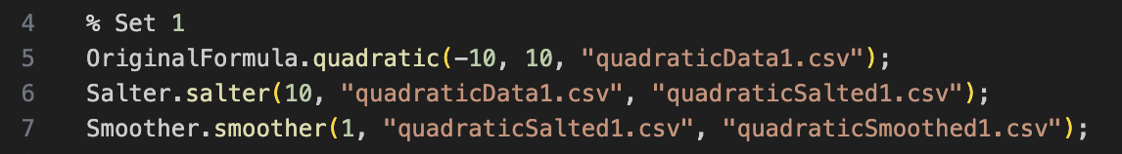

#### Output:

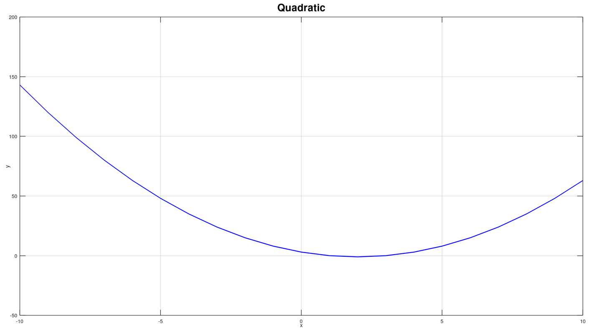

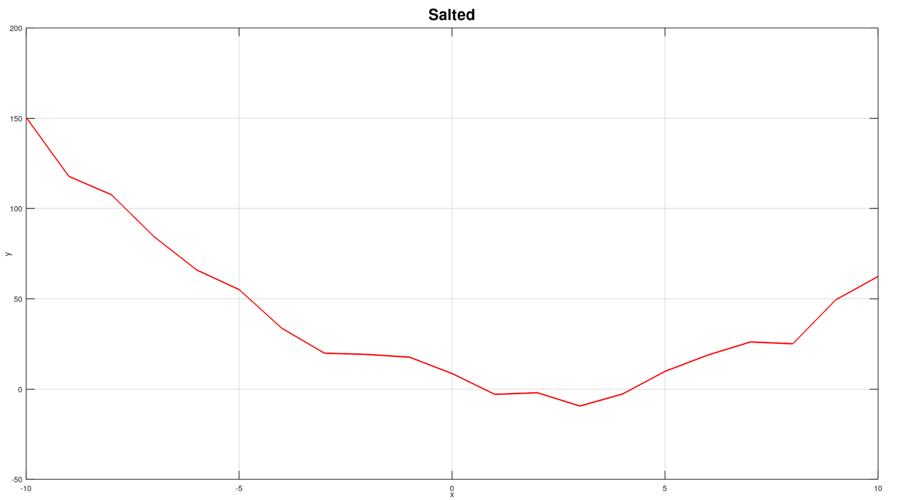

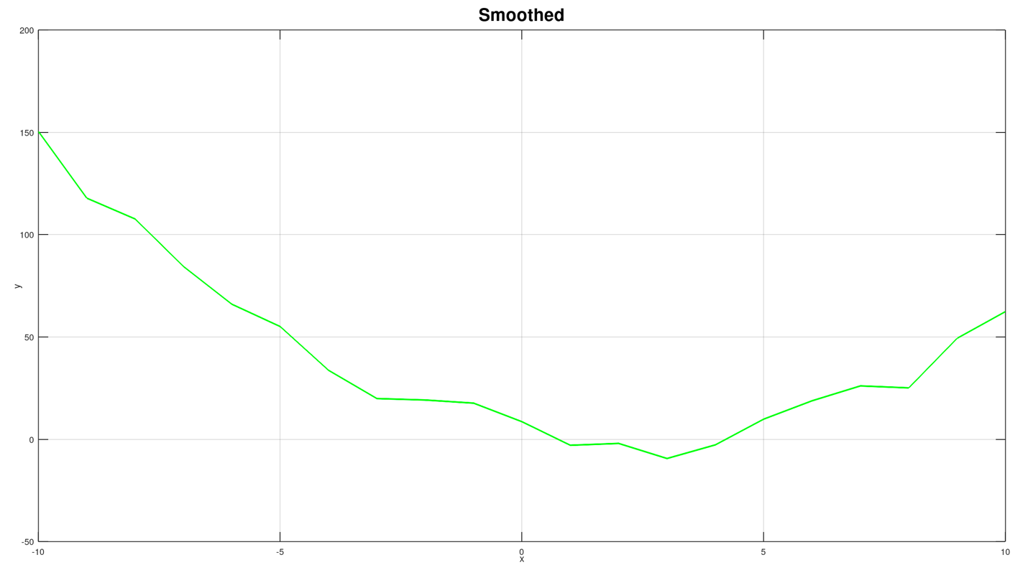

#### Set 2 Quadratic Code:

Lines 9-12 runs the second set of the quadratic function. It uses the bounds of -25 to 25, uses the salted range of 25, and the window size of 3.

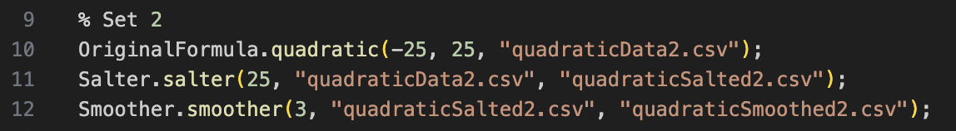

#### Output:

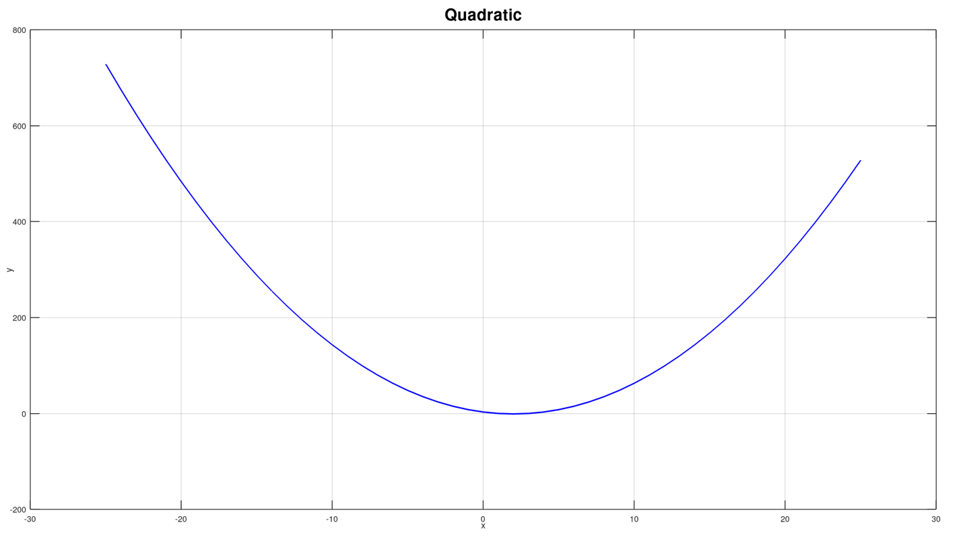

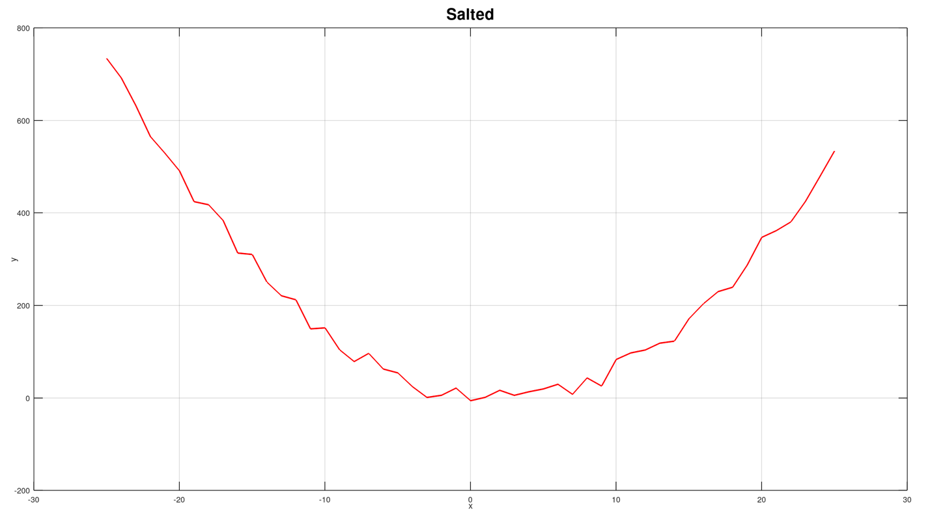

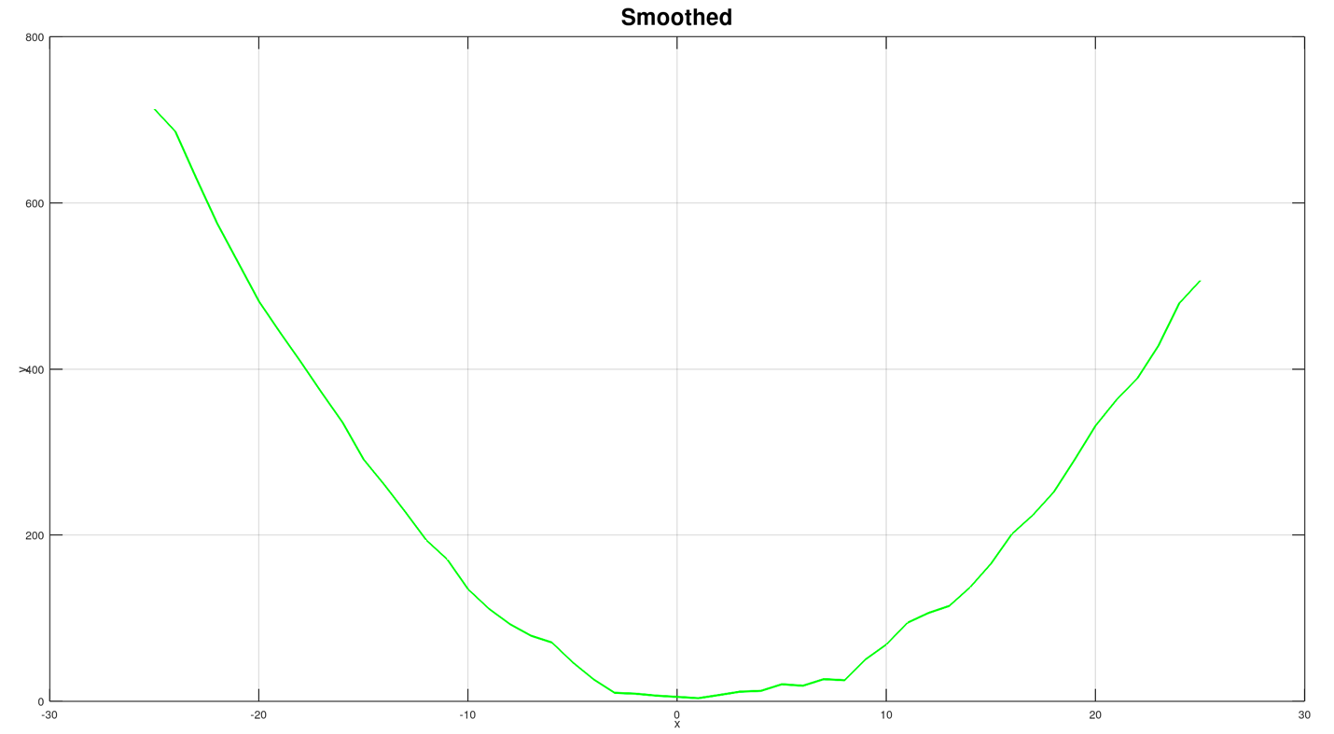

#### Set 3 Quadratic Code:

Lines 14-17 runs the third set of the quadratic function. It uses the bounds of -50 to 50, uses the salted range of 50, and the window size of 7.

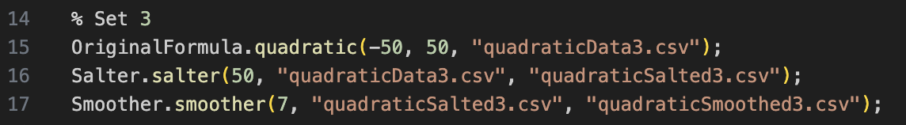

#### Output:

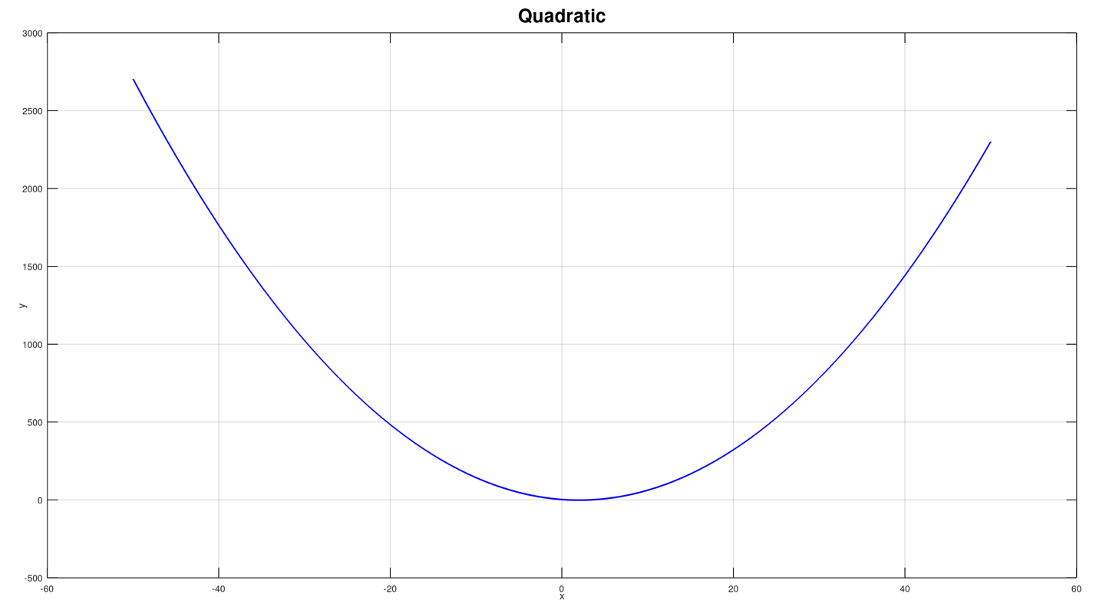

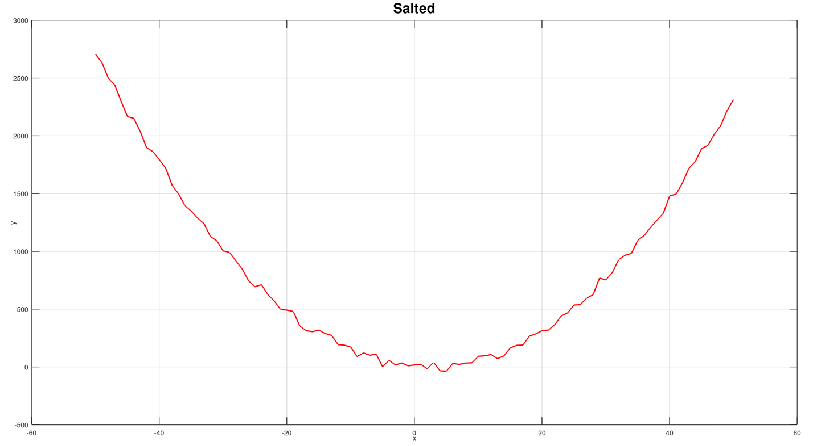

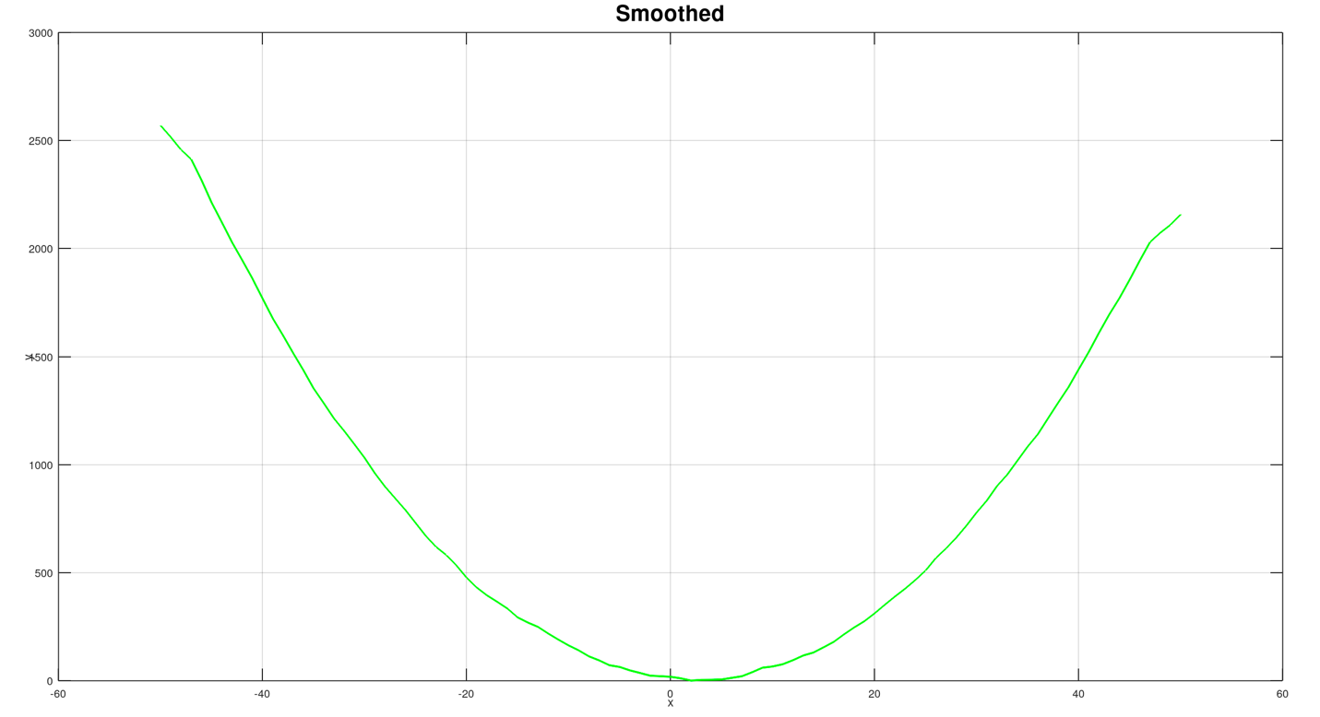

#### Set 1 Sine Code:

Lines 19-22 runs the first set of the sine function. It uses the bounds of -10 to 10, uses the salted range of 50, and the window size of 1.

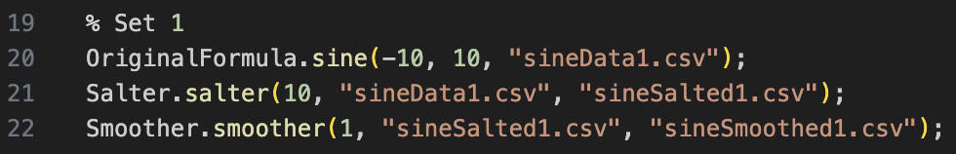

#### Output:

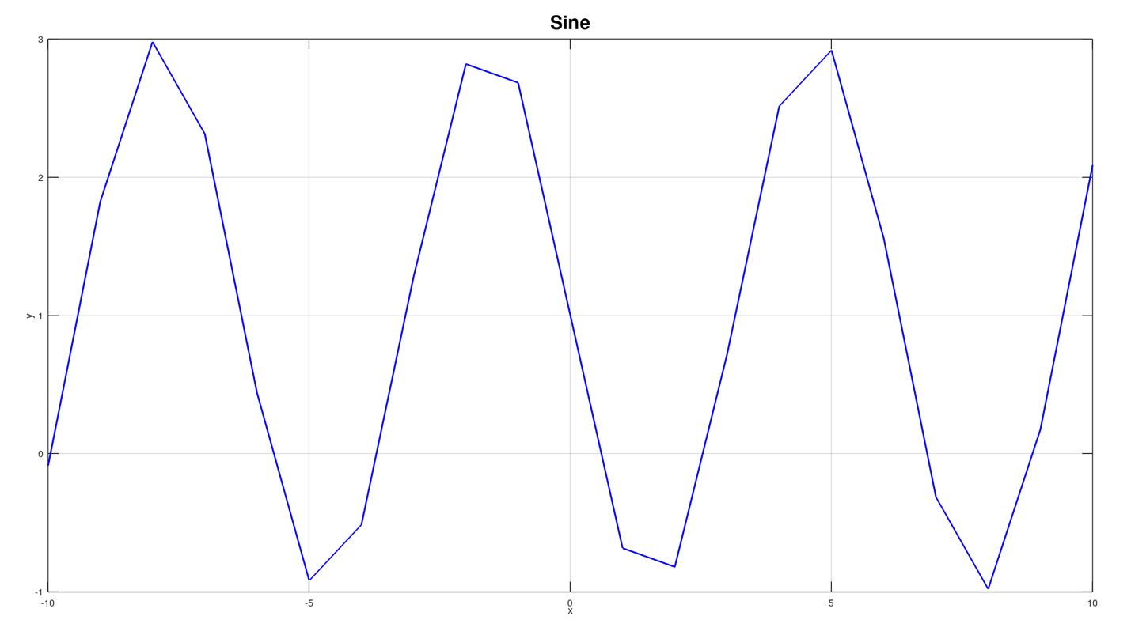

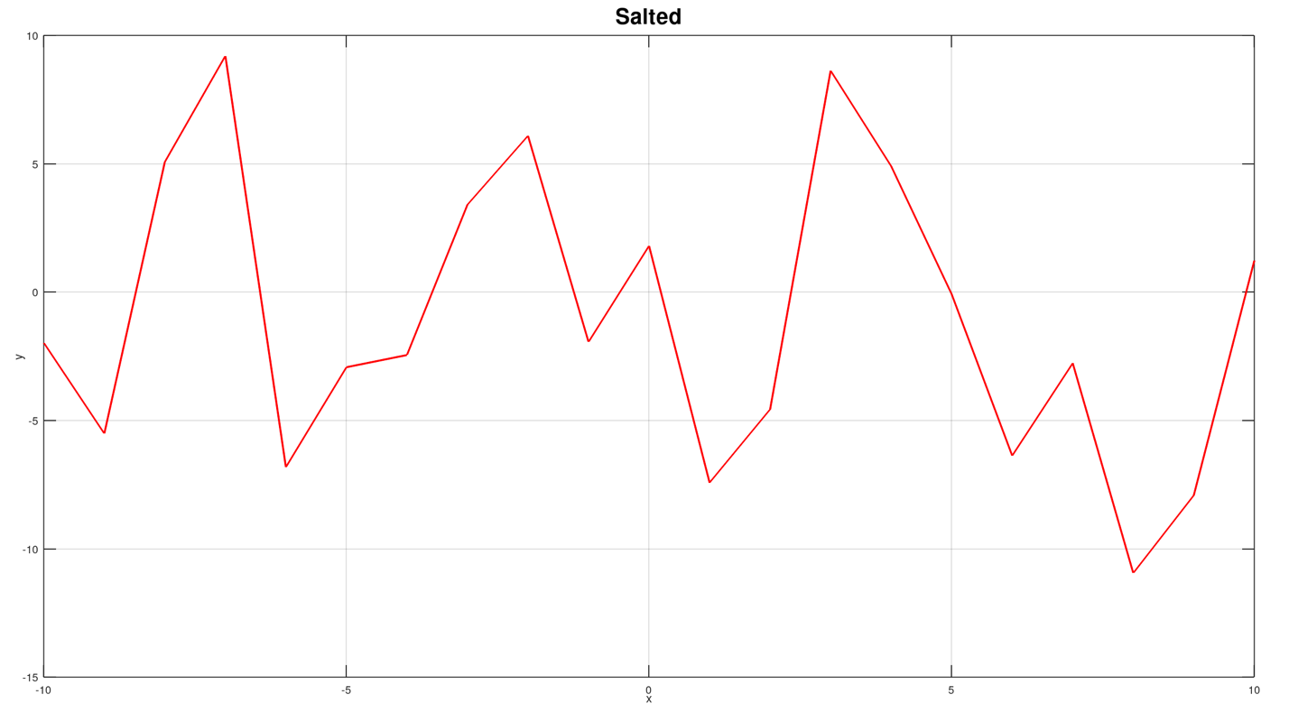

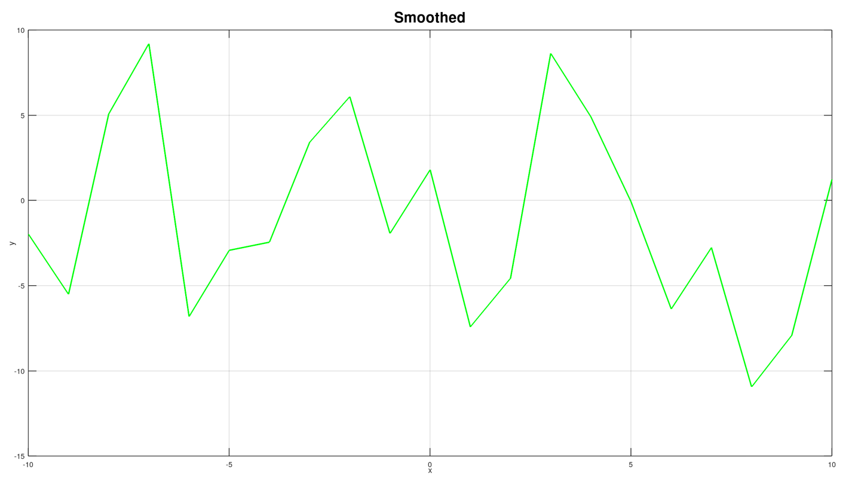

#### Set 2 Sine Code:

Lines 24-27 runs the first set of the sine function. It uses the bounds of -25 to 25, uses the salted range of 25, and the window size of 3.

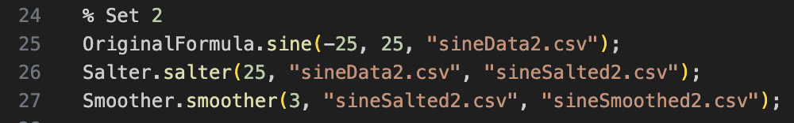

#### Output:

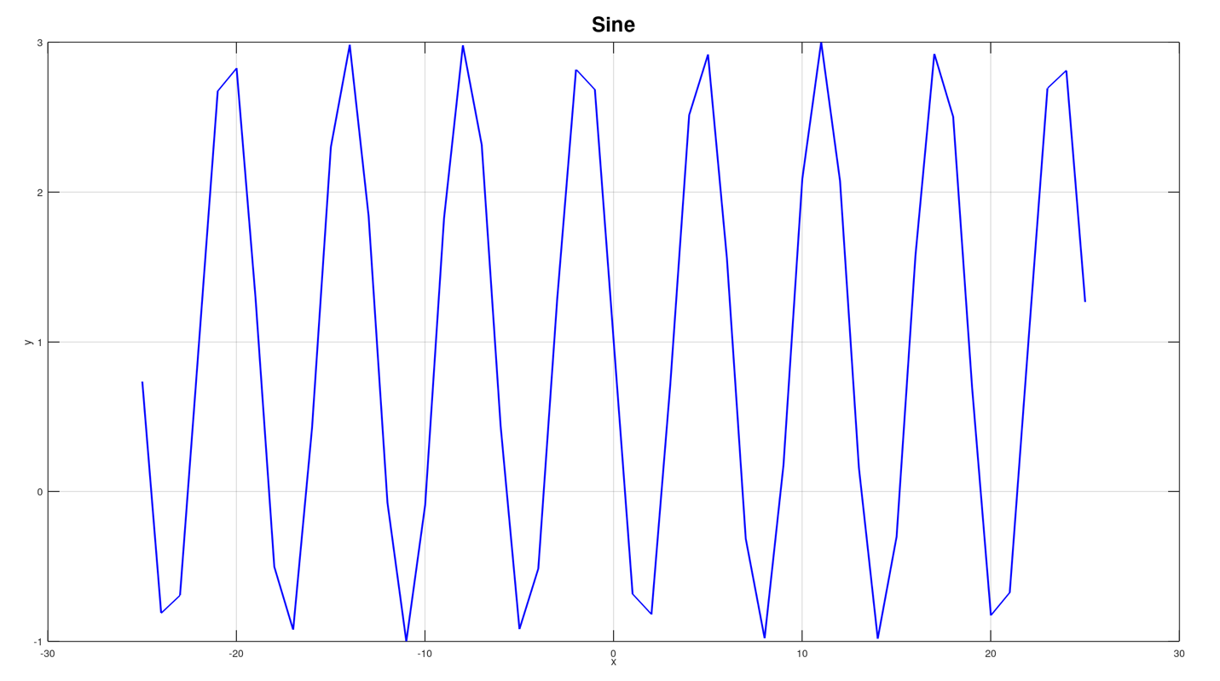

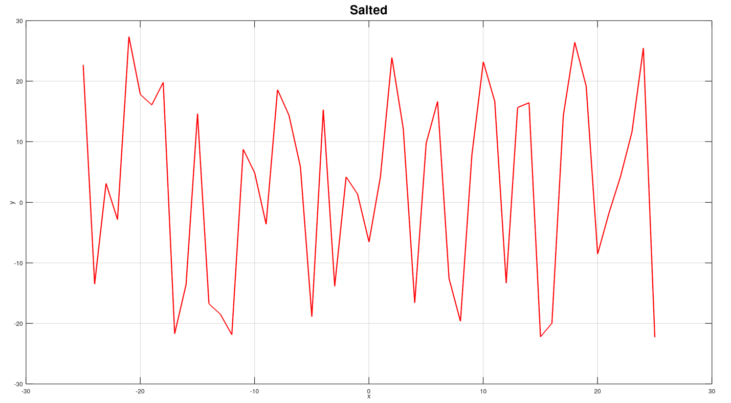

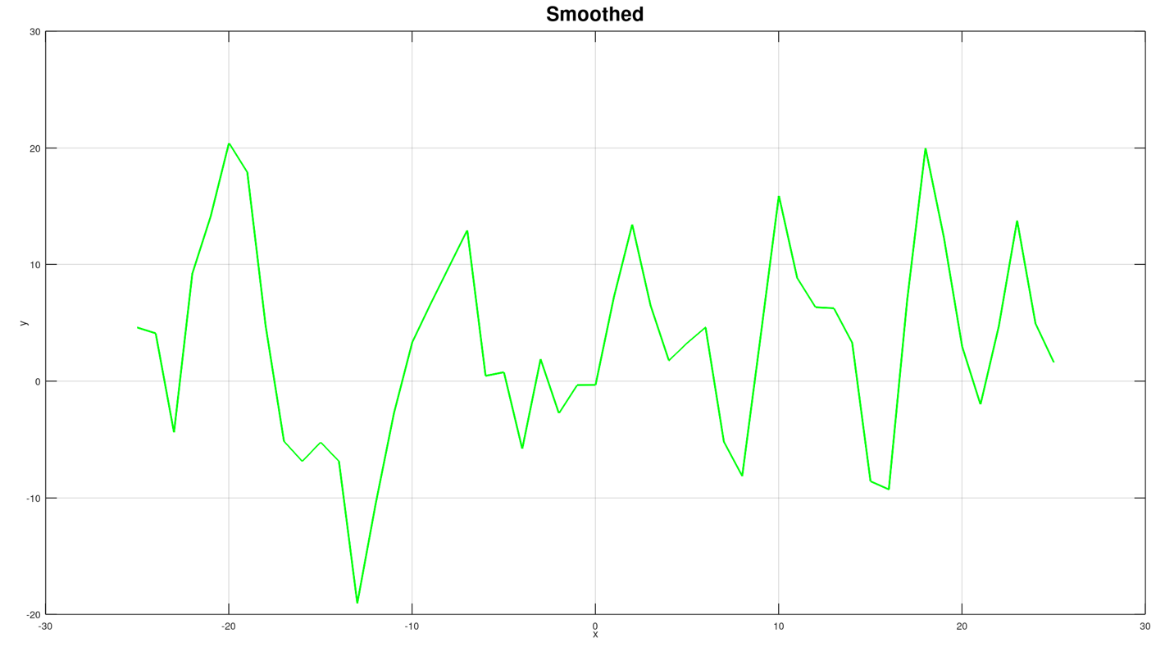

#### Set 3 Sine Code:

Lines 29-32 runs the first set of the sine function. It uses the bounds of -50 to 50, uses the salted range of 50, and the window size of 7.

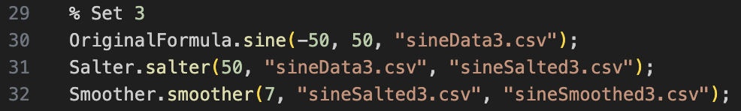

#### Output:

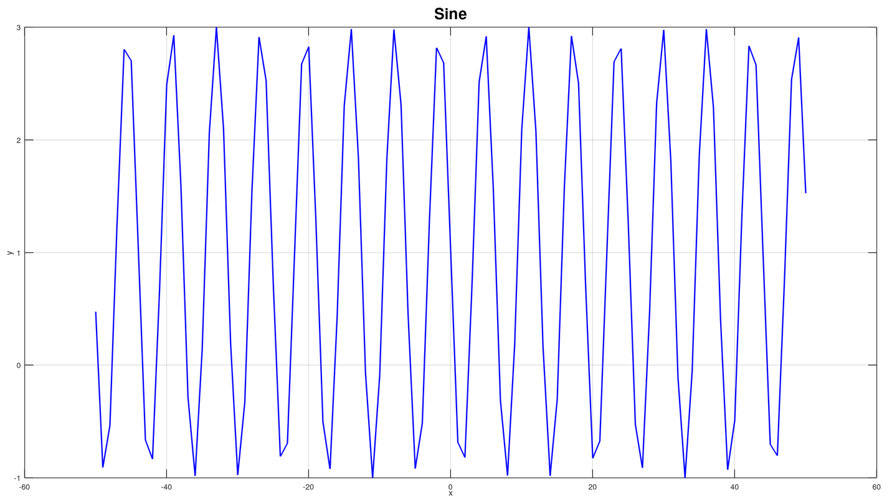

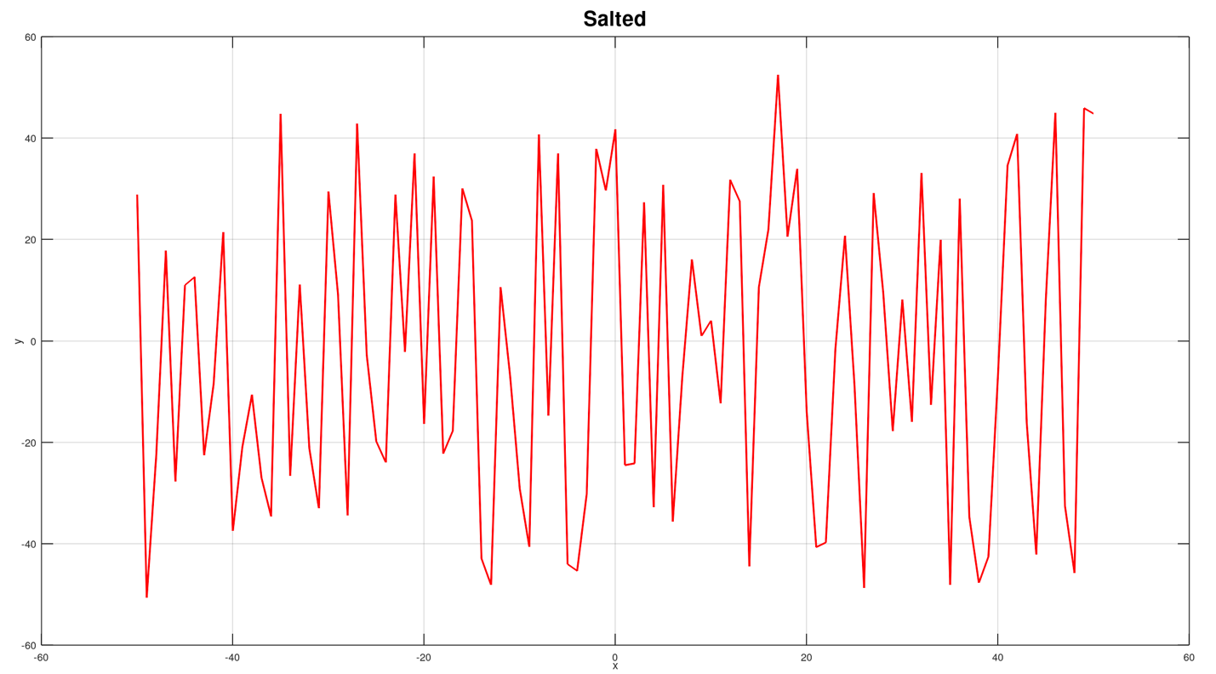

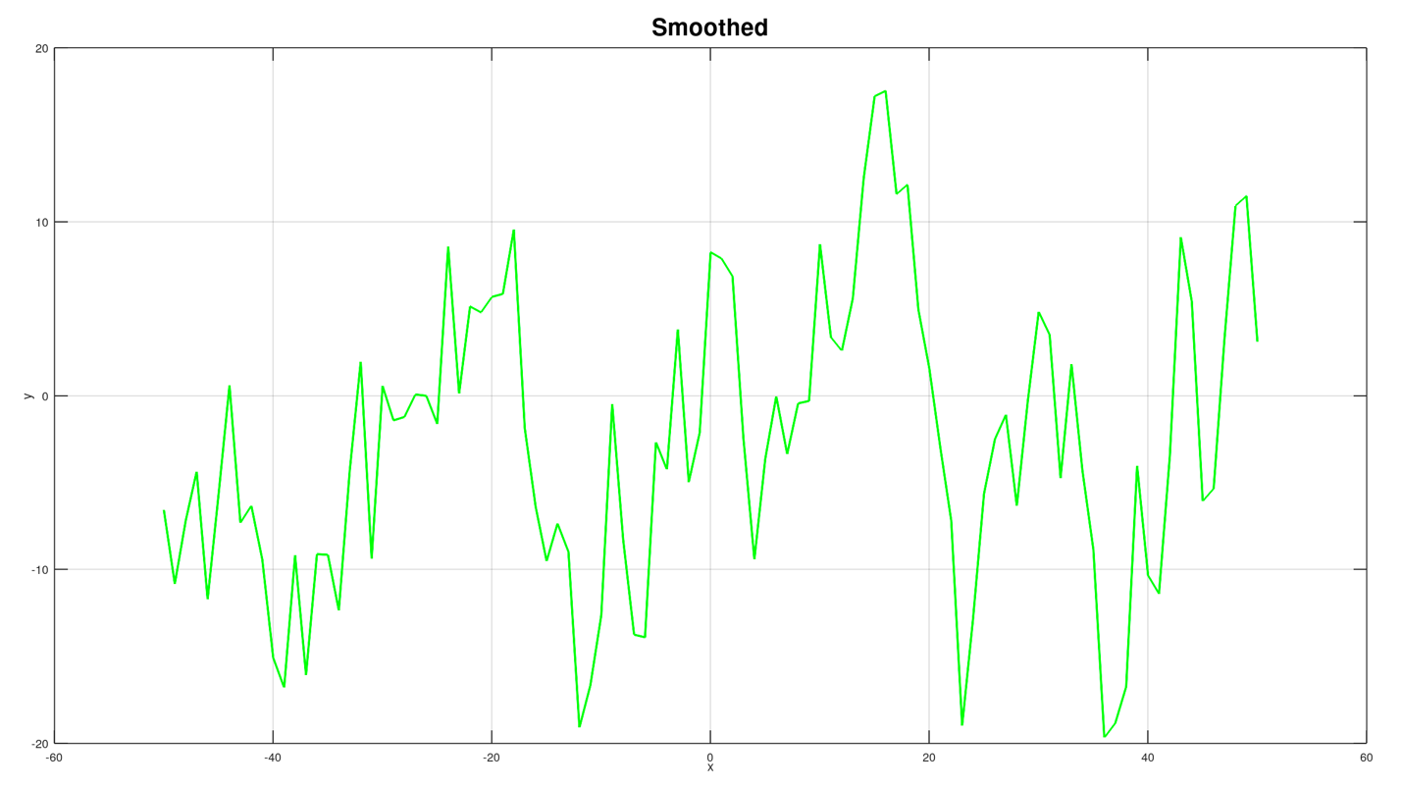

#### Set 1 Absolute Code:

Lines 34-37 runs the first set of the sine function. It uses the bounds of -10 to 10, uses the salted range of 10, and the window size of 1.

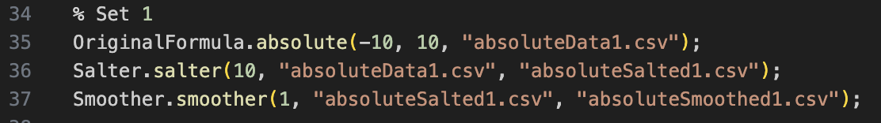

#### Output:

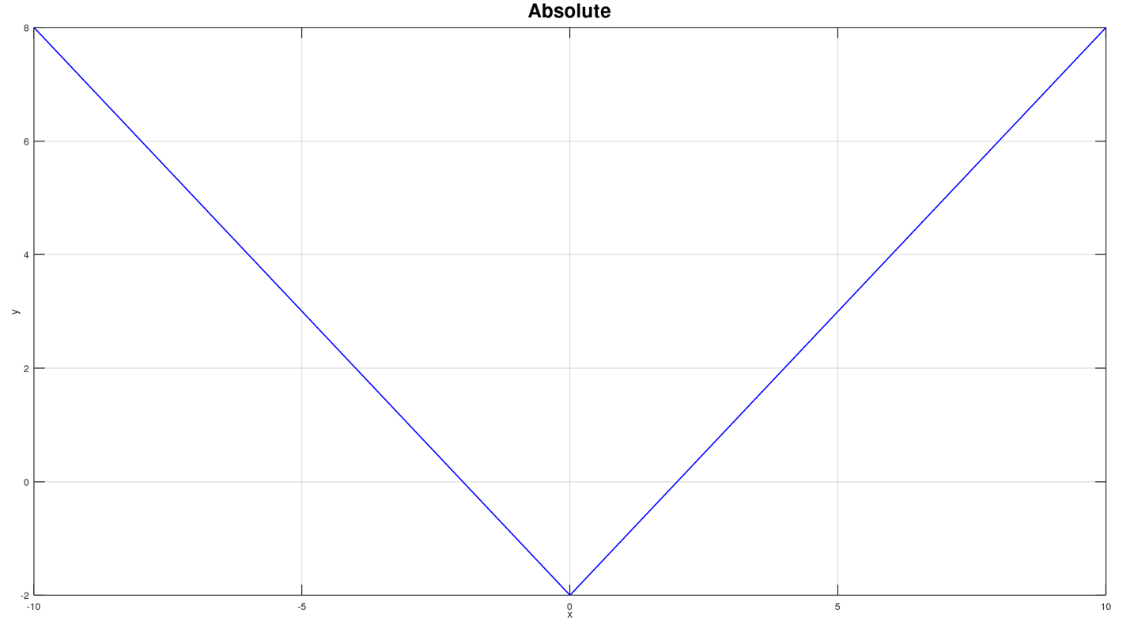

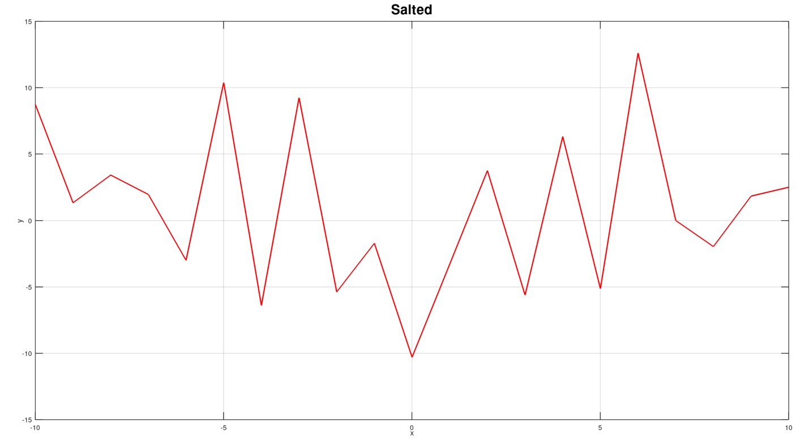

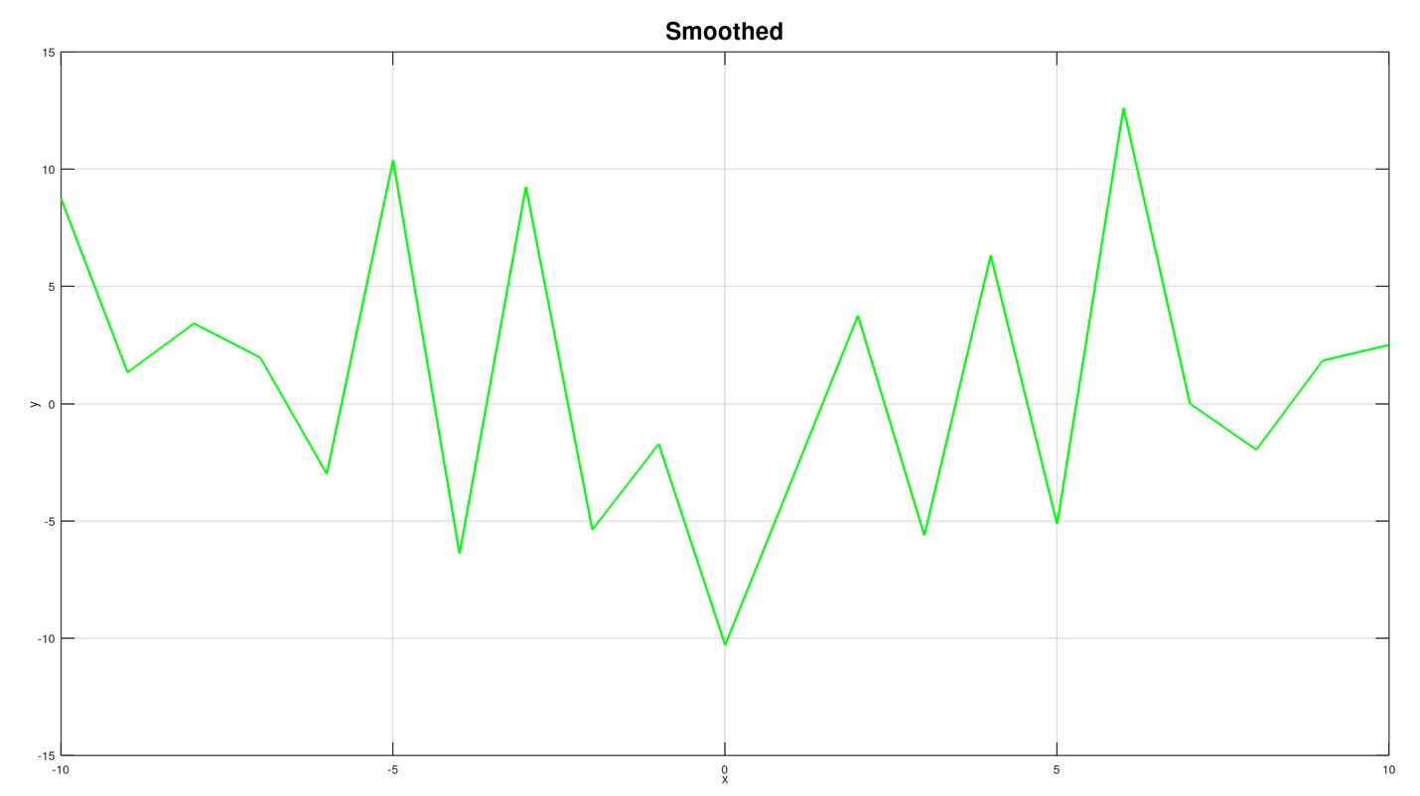

#### Set 2 Absolute Code:

Lines 39-42 runs the first set of the sine function. It uses the bounds of -25 to 25, uses the salted range of 25, and the window size of 3.

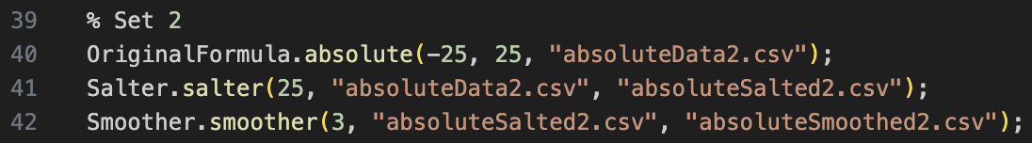

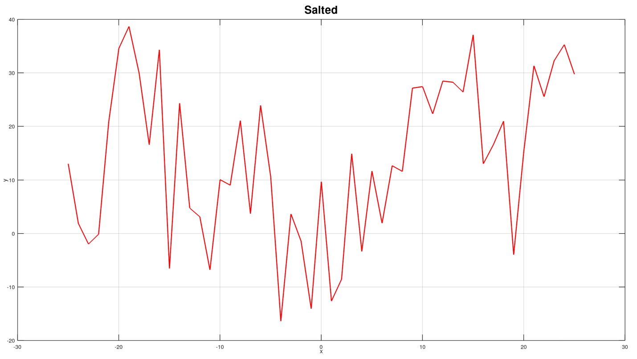

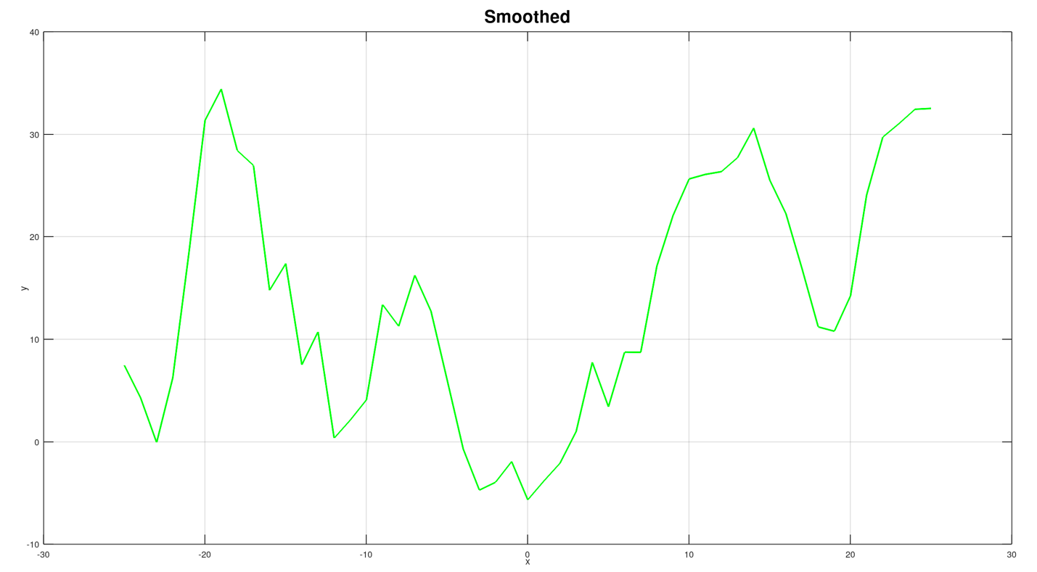

#### Set 3 Absolute Code:

Lines 44-47 runs the first set of the sine function. It uses the bounds of -50 to 50, uses the salted range of 50, and the window size of 7.

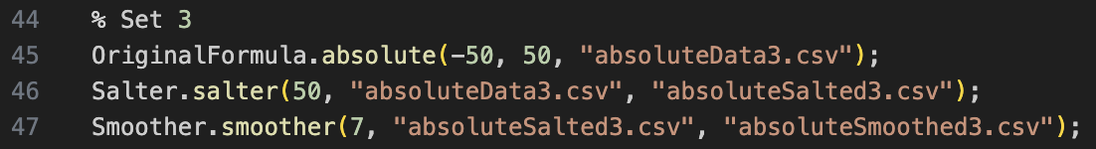

#### Output:

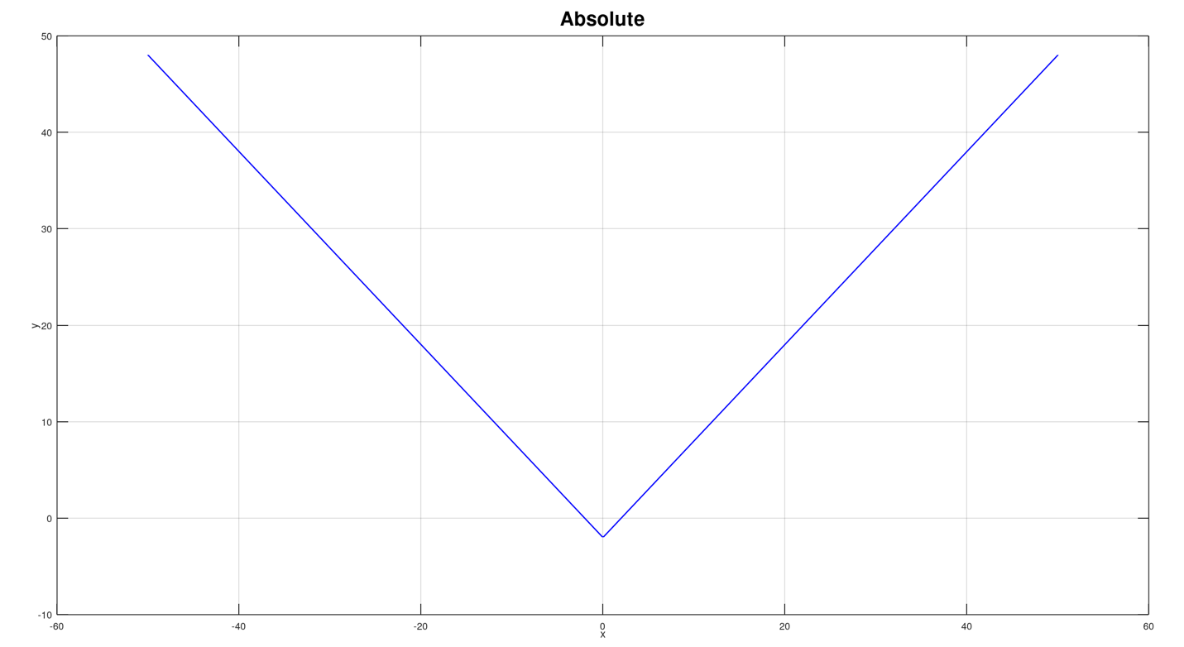

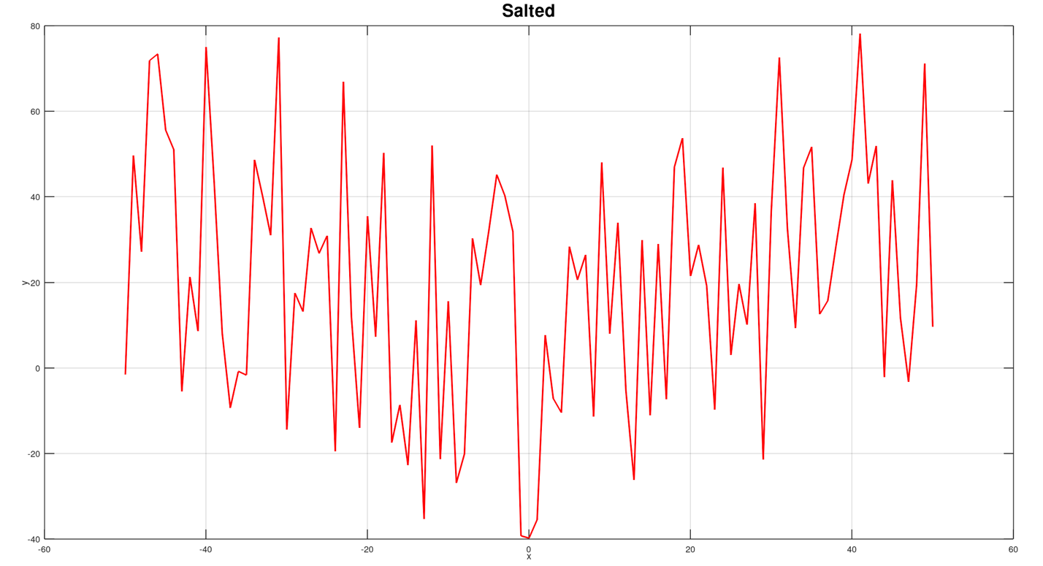

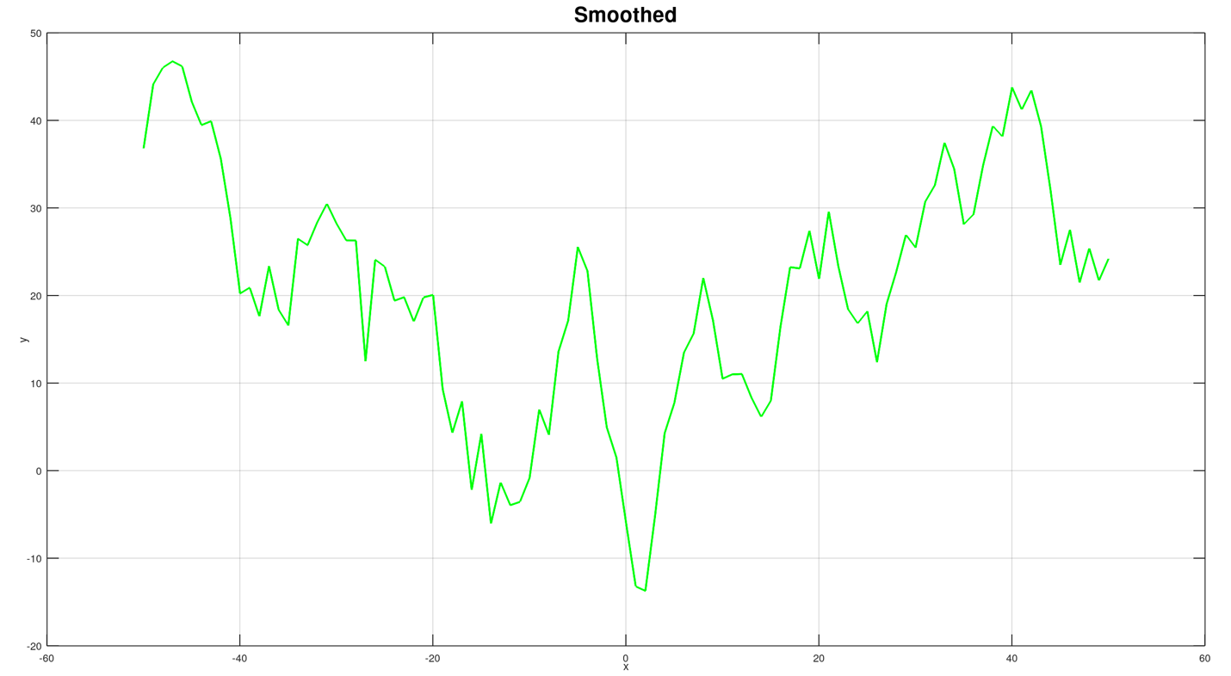

### OriginalFormula.m

#### Quadratic Function

The code creates a quadratic function that takes in the parameter of lowerbound, upperbound, and outputfile. You can manually change the bounds so its easier to get varied results. The file parameter also allows for the name of the output csv file so it doesn’t continuously make new files every time and just overwrites over one if a csv file is created. It uses the formula $y=x^{2}-4x+3.$ Using the datahandler class from the DataHandler file, it's able to save the x and y values to the output file which is set by the parameter.

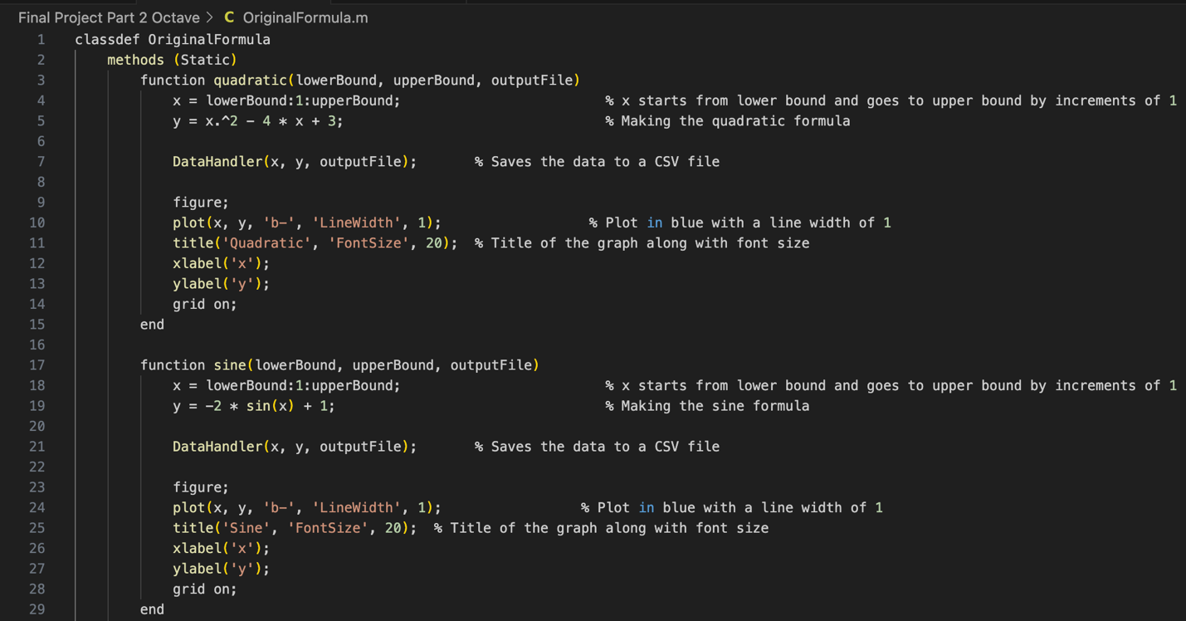

#### Sine Function

The code creates a sine function that takes in the parameters lowerbound, upperbound, and outputfile. You can change the bounds manually. The outputFile parameter allows for the name of the output csv file so it doesn’t continuously make new files every time and just overwrites over one if a csv file is created. The formula being used is y $=-2\sin\left(x\right)+1$. Just like the other functions, it uses the dataHandler from the DataHandler file to save the x and y values to the output file that’s passed in.

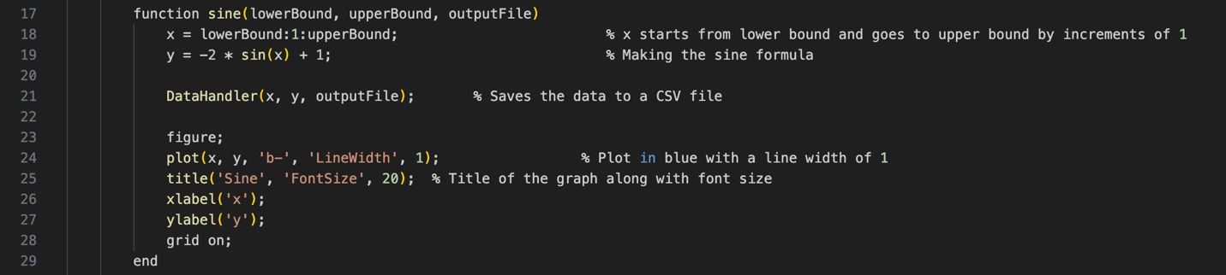

#### Absolute Function

The code creates an absolute value function that takes in the parameters lowerbound, upperbound, and outputfile. You can manually adjust the bounds depending on how much of the graph you want to display. The outputFile parameter lets you name the CSV file so it doesn’t create a new one every time — instead, it will overwrite an existing file if one already exists. The formula being used is y = |x| - 2. Like the other functions, it uses the dataHandler from the DataHandler file to save the x and y values into the output file that’s provided.

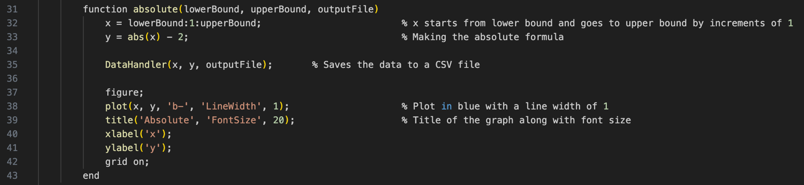

### Salter.m

The salter function reads the csv file from thanks to the csvread function. It reads the csv file and skips the first line, or header. The header just says “x, y” so it’s not necessary for the program to read it. Afterwords it puts all x values in the first column and all y values in the second column. It applies the salting algorithm, which takes a random number in between the given salt range and adds that to the y. Afterwords, it writes the new salted y value back to the outputFile which is handled by the DataHandler File. It then prints out the salted graph.

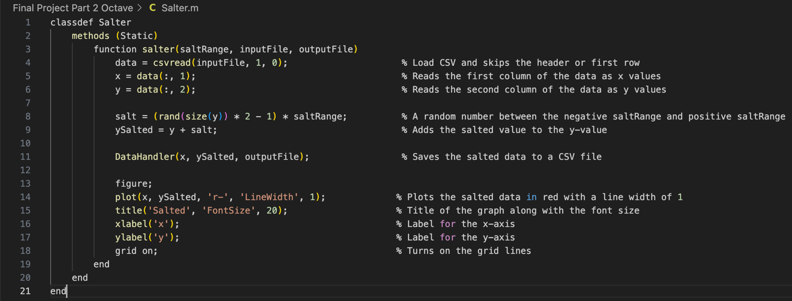

### Smoother.m

The smoother function copies the same method of reading the csv file as the salting function. It reads and ignores the first row. It then checks if the given windowSize variable is greater than 1. This is set through the parameter, but if the windowSize is less then 1 then the code asks you to change the value. If the windowSize is 1, it will return the same values as before since the value hasn’t moved any places. If the windowSize is anything else, it applies the smoothing algorithm to it. It averages the y value with the windowSize, and that becomes the value of the new y. This is then stored into a new csv file with the DataHandler function through the DataHandler file. Afterwords, it plots the graph.

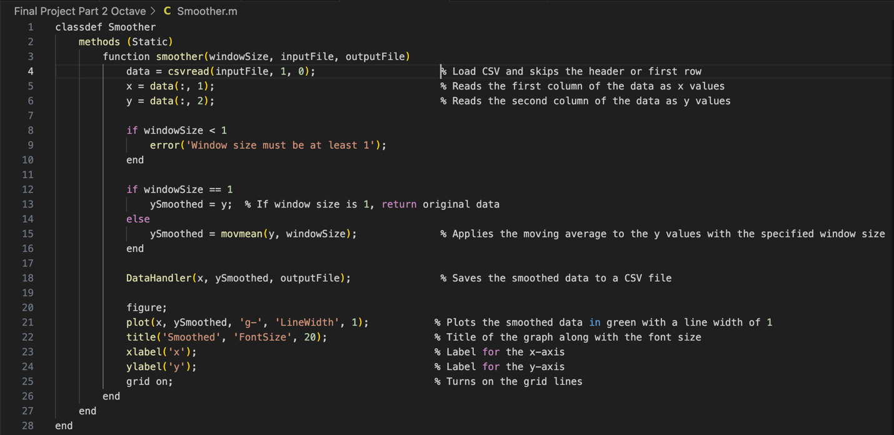

### DataHandler

The dataHandler function opens a file using the fopen function. The file that’s being opened is determined through the values of the parameter. Afterwords the “w” means to write, so it writes into the file. The fprint function in line 3 writes the heading of the file, which is “x, y”. The fprint function in line 4 writes the values of x and y into the file.

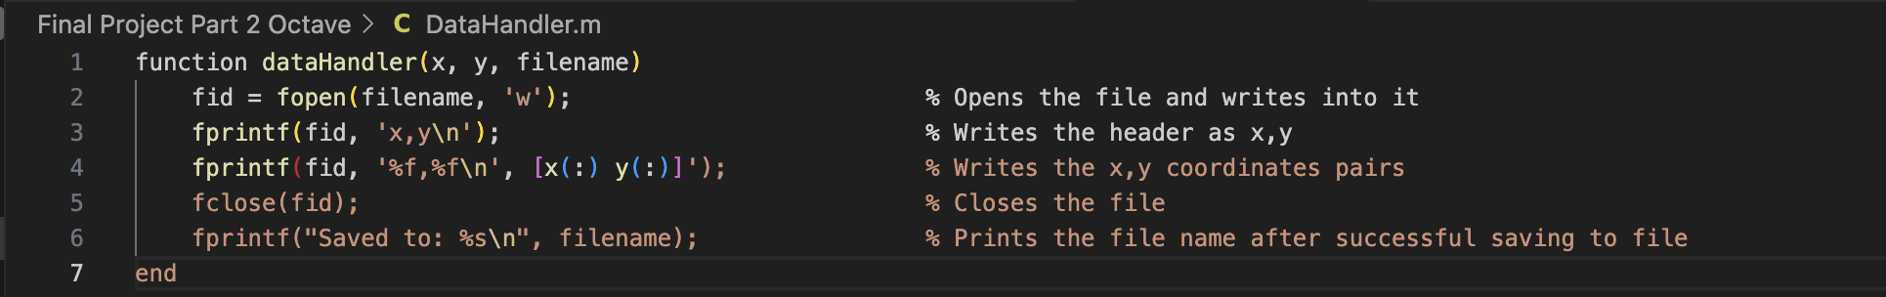

## What is Octave (1 Page Paper)

Octave is an open-source software and programming language. It is widely used as an alternative to Matlab because it’s free compared to the paid software Matlab. Octave is mostly used to graph mathematical functions in both 2D and 3D rendering. Since it’s an open-source program, it has received many useful updates that people themselves have suggested. One reason for its popularity is because of how similar Octave is to Matlab. So, if you were to able to learn and code in the Octave software, then you have also learned how to work in Matlab. Because of how little the difference between the two are, people tend to use Octave for the majority of their project and only tend to switch to Matlab if Octave is missing some functionality.

Octave is very similar to java and the syntax used. They both use similar syntax, so a feeling of familiarity helps approach people who are new to using the software. One of the biggest differences between java and octave is the use of semicolon. In java, semicolons mark the end of a statement or line. It tells the computer that everything before the semicolon is together and should be read as such. In octave it’s a bit different. The semicolon at the end of a line stops it from being displayed at the system. In the Octave language, every line is run and shown in the system after compiling. The use of the semicolon stops the system from displaying that line. In a sense, it can be seen as a stopper which is completely different from java.

Octave is mainly used for graph creation, data plotting, matrix operations, and numerical calculations. Because of its wide range of uses in math related subject, it’s often used in engineering, physics, and data science. It is especially useful in situations where data or graphs needs to be visualized and shown. It’s proficient in both 2D and 3D data models and rendering. It’s easy and friendly to use for beginners and doesn’t take long to become proficient in. It’s usage of short and easy code to give out the results make it great for beginners as well.

# Part 3: JFree

# Final Report

## Abstract

The Breast Cancer Wisconsin dataset includes information from nearly 700 breast tissue samples that have been examined during biopsies. 10 various features define each sample, including how thick the clumps of cells are, how normal the cells look, and how often they divide. These features are given 1-10 ratings. Each sample is also labeled as benign (non-cancerous) or malignant (cancerous). This information enables us to explore trends in the traits that may be linked with cancer through use of the statistics.

## Question 1

A random sample of almost 700 patient records was used to create the histogram below. Based on what pathologists saw in cell samples, each bar displays the relative frequency of Clump Thickness scores (ranging from 1 to 10). One of the most crucial visual characteristics for tumor diagnosis is lump thickness. Elevated scores could indicate strange growth patterns linked to cancer.

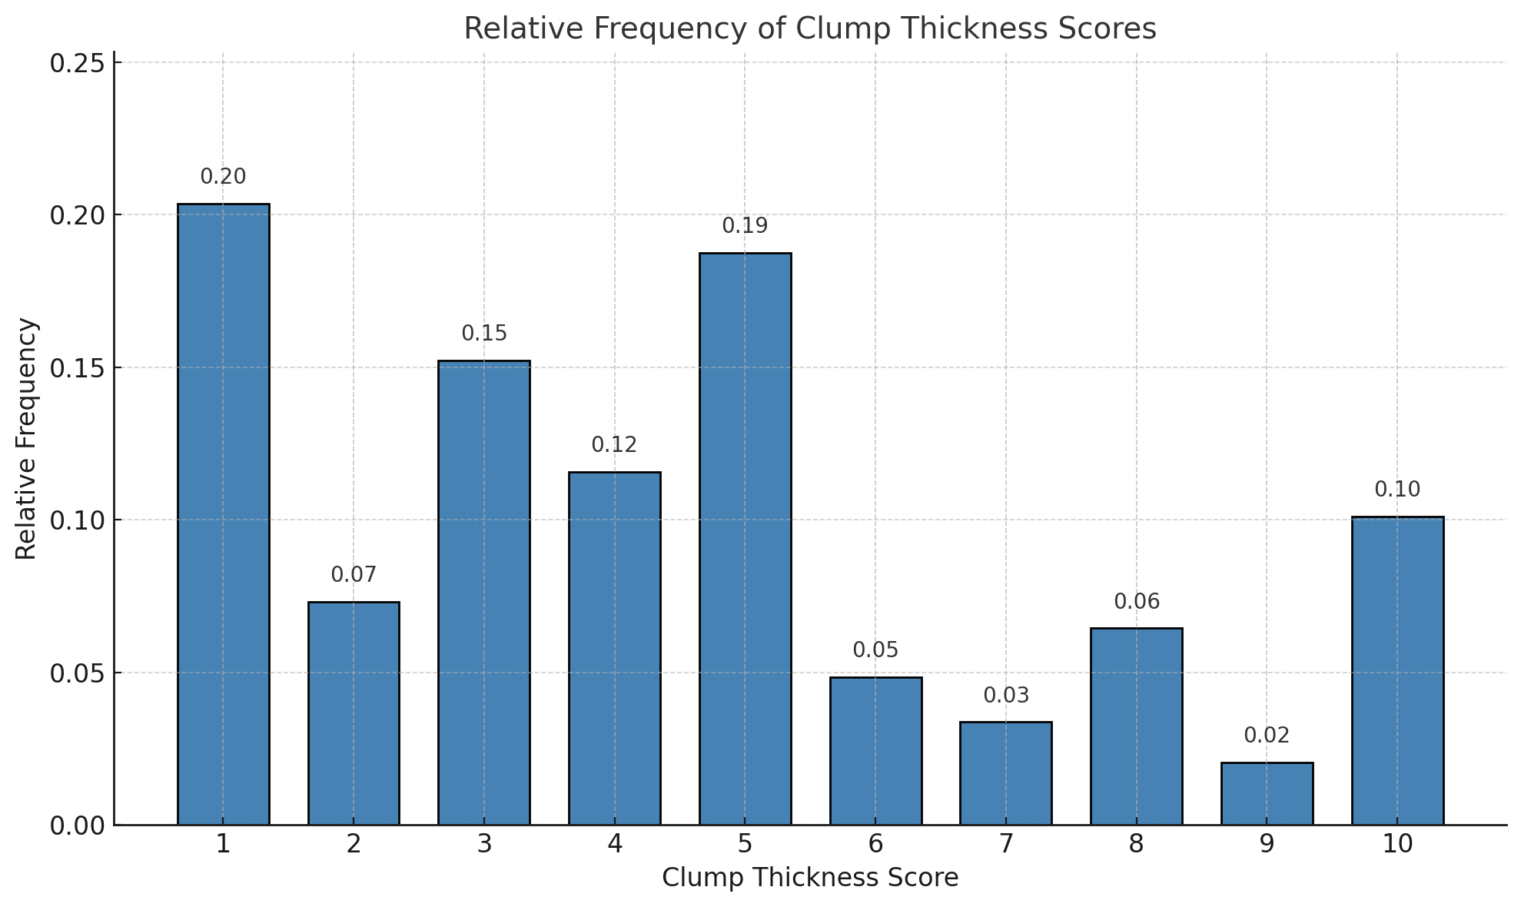

a) Use the histogram to determine which clump thickness score was the most common among the patients.

b) What proportion of patients had Clump Thickness scores greater than 5?

c) What proportion of patients had scores between 2 and 7, inclusive? What might this range suggest about typical tissue behavior?

### Answer

a) Clump thickness score that was the most common was rating was clump thickness score 1.

b)

$$P \left(Clump Thinkness>5\right)=P\left(6\right)+P\left(7\right)+P\left(8\right)+P\left(9\right)+P\left(10\right)$$

$$0.048+0.033+0.061+0.022+0.103=0.268$$

The proportions of patients that had a clump thickness score greater than 5 was 26.8%

c) About 61.1% of patients had scores ranging between 2 and 7. This shows that about more than half of people fall within this range.

$$P\left(2 ≤X ≤7\right)=P\left(2\right)+P\left(3\right)+P\left(4\right)+P\left(5\right)+P\left(6\right)+P\left(7\right)$$

$$0.073+0.151+0.121+0.188+0.048+0.033=0.611$$

Reference: #1.6 page 7.

## Question 2

Q2. A patient case is selected at random from the following 10 cases, each labeled by their diagnosis: {2, 2, 2, 4, 2, 2, 2, 2, 4, 4} (Where 2 = Benign, 4 = Malignant)

a) What is the sample space for this experiment?

b) Based on this sample, what is the probability that a randomly chosen patient has a benign tumor?

c) What is the probability that the patient has a malignant tumor?

### Answer

a) The sample space for this experiment is {Benign, Malignant}

b) The probability that someone randomly chosen has a benign tumor is 70%.

$$P\left(Benign\right)= \frac{7}{10}= .7$$

c) The probability that the patient has malignant tumor is 30%.

$$P\left(Malignant\right)= \frac{3}{10}= .3$$

Reference: #2.10 page 32.

## Question 3

Refer to question 2’s answer, Q4. Each patient in a hospital study is independently diagnosed as either benign or malignant. 70% of patients are diagnosed with benign tumors, and 30% are diagnosed with malignant tumors. **A group of 5 patients is selected at random**.

a) What is the probability that all 5 patients are diagnosed as benign?

b) What is the probability that at least one of the 5 patients is malignant?

### Answer

a) The probability that all 5 patients are diagnosed as benign is 16.8%

$$P(All Benign)=0.75=0.16807$$

b) The probability that at least one of the 5 patients is malignant is 83.2%

$$P\left(x ≤4 benign\right)=1-P\left(x=5 benign\right)=1-0.16807=0.83193$$

Reference: #2.75 page 56.

## Question 4

A hospital study showed that 30% of patients were diagnosed with malignant tumors. Further analysis revealed that 60% of the patients with high Clump Thickness scores (≥ 5) had malignant tumors, while only 10% of the patients with low Clump Thickness scores (< 5) had malignant tumors. **A new patient is randomly selected from the study**.

a) What is the probability that the patient has a malignant tumor, given that their Clump Thickness score is high (≥ 5)?

b) What is the probability that the patient has a benign tumor, given that their Clump Thickness score is low (< 5)?

### Answer

a) The probability that the patient has a malignant tumor given that their clump thickness score is high is 60%.

$$P(Malignant∣High Clump)=0.6$$

b) The probability that the patient has a benign tumor given that their clump thickness score is low is 90%.

$$P(Benign∣Low Clump)=1-P(Malignant∣Low Clump)=1-0.1=0.9$$

Reference: #2.76 page 56.

## Question 5

$$P\left(A\right)= 0.4, P\left(B\right)= 0.5, P\left(A∪B\right)=0.75$$

Find the following:

a) $P(A∩B)$

b) $P(\overline{A}∪\overline{B})$

c) ) $P(\overline{A}∩B)$

### Answer

a) 0.15

$$P\left(A∩B\right)=P\left(A\right)+P\left(B\right)-P(A∩B)$$

$$P\left(A∩B\right)= 0.4+0.5-0.75=0.15$$

b) 0.85

$$P\left(\overline{A}∪\overline{B}\right)=1-0.15=0.85$$

c) 0.35

$$P\left(\overline{A}∩B\right)=P\left(B\right)-P(A∩B)$$

$$P\left(\overline{A}∩B\right)=0.5-0.15=0.35$$

Reference: #2.95 page 60.

## Question 6

A group of 10 patient records is randomly selected from the dataset. Let the random variable 𝑌represent the number of patients in the sample who have a Clump Thickness score of 7 or higher. From the sample below:

$$\{5, 1, 4, 7, 1, 10, 3, 3, 10, 6\}$$

a) Construct the probability distribution for 𝑌, the number of “high Clump Thickness” patients (score ≥ 7).

b) What is the probability that fewer than 2 patients in the group have a Clump Thickness score of 7 or more?

### Answer

a) The number of patients who have a high clump thickness is 3. This happened in our sample 1 time, so the probability distribution from the sample is 1.

$$\{7, 10, 10\}$$

$$P\left(Y=3\right)=1$$

b) From the sample, we saw that only Y = 3 is the only value that was observed, everything before that was 9. So, the probability that fewer than 2 patients in the group have a clump thickness of 7 or more is 0.

$$P\left(Y<2 \right)=0$$

Reference: #3.1 page 90.

## Question 7

A patient is randomly selected and assigned a risk category based on test results. The patient receives a classification of:

* High Risk with probability 0.15 and associated treatment cost of $20,000
* Moderate Risk with probability 0.30 and cost of $8,000
* Low Risk with probability 0.55 and cost of $2,000

Let Y be the cost of treatment for a randomly selected patient. What is the expected cost (expected value of 𝑌) for treatment per patient?

### Answer

The expected cost for treatment per patient is $6,500

Use the expected value formula:

$$E\left(Y\right)=\sum{[y_{1}}×P\left(y_{1}\right)]$$

$$E\left(Y\right)=20000\left(0.15\right)+8000\left(0.30\right)+2000(0.55)$$

$$E\left(Y\right)=3000+2400+1100=6500$$

Reference: #3.23 page 99.

## Question 8

In a medical study, 70% of patients respond positively to a new medication. Patients are interviewed one at a time. Let 𝑌 be the number of patients that need to be interviewed to find the first one who responds positively.

a) What is the probability that exactly 4 patients need to be interviewed to encounter the first positive response?

b) What is the probability that at least 5 patients need to be interviewed before observing a positive response?

### Answer

a) The probability that exactly 4 patients need to be interviewed to encounter the first positive response is 1.89%.

$$P\left(Y=4\right)={(1-p)}^{3}∙p$$

$$P\left(Y=4\right)={(0.3)}^{3}∙0.7=0.027∙0.7=0.0189$$

b) The probability that at least 5 patient needs to be interviewed before observing a positive response is 0.81%.

$$P\left(Y≥5\right)={(1-p)}^{4}$$

$$P\left(Y≥5\right)={(0.3)}^{4}=0.0081$$

Reference: #3.78 page 120.

## Question 9

A diagnostic kit contains 6 sample strips, 2 of which are defective. Three strips are selected at random without replacement and tested. Let 𝑌 represent the number of defective strips in the sample.

a) Find the probability distribution of 𝑌 where 𝑌= 0, 1, 2.

b) Compute the **mean** and **variance** of Y.

### Answer

a) The probability distribution where Y =0, 1, 2 is:

Use hypergeometric probability function.

$$P\left(Y=0\right)= \frac{\left({2 \atop 0}\right)∙({4 \atop 3})}{({6 \atop 3})}=\frac{1∙4}{20}=.20$$

$$P\left(Y=1\right)= \frac{\left({2 \atop 1}\right)∙({4 \atop 2})}{({6 \atop 3})}=\frac{2∙6}{20}=.60$$

$$P\left(Y=2\right)= \frac{\left({2 \atop 2}\right)∙({4 \atop 1})}{({6 \atop 3})}=\frac{1∙4}{20}=.20$$

b) Mean is 1

$$E(Y)=\sum{y_{1}}​⋅P(Y=y_{1}​)=0(0.20)+1(0.60)+2(0.20)=1.0$$

$$μ=E\left(Y\right)=1.0$$

Variance is 0.40

$$E(Y2)=0^{2}(0.20)+1^{2}(0.60)+2^{2}(0.20)=0+0.60+0.80=1.40$$

$$Var(Y)=E(Y^{2})-{[E\left(Y\right)]}^{2}=1.40-1.00=0.40$$

Reference: #3.115 page 130.

## Question 10

In a hospital lab, samples arrive at an average rate of 12 per hour. A technician takes a 3-minute break. Let 𝑌 be the number of samples that arrive during the break. What is the probability that at least one sample arrives during the technician's break?

### Answer

The probability that at least one sample arrives during the technician’s break is 45.12%.

$$P(Y≥1)=1-P(Y=0)$$

Use Poisson formula to find:

$$P(Y=0)=\frac{e^{-μ}⋅μ^{0}}{0!}​=e^{-0.6}$$

$$P(Y≥1)=1-e^{-0.6}≈1-0.5488=0.4512$$

Reference: #3.128 page 136.

## Question 11

A screening test is given to 4 patients. Each patient independently has a 60% chance of receiving a positive result. Let 𝑌 be the number of patients who test positive.

a) Use the binomial probability formula to calculate the probabilities for 𝑌=0,1,2,3,4

b) Compute the expected value and standard deviation of 𝑌.

### Answer

a)

$$P\left(Y=0\right)=\left({4 \atop 0}\right){(0.6)}^{0}{(0.4)}^{4}=1⋅1⋅0.0256=0.0256$$

$$P\left(Y=1\right)=\left({4 \atop 1}\right){(0.6)}^{1}{(0.4)}^{3}=4⋅0.6⋅0.064=0.1536$$

$$P\left(Y=2\right)=\left({4 \atop 2}\right){(0.6)}^{2}{(0.4)}^{2}=6⋅0.36⋅0.16=0.3456$$

$$P\left(Y=3\right)=\left({4 \atop 3}\right){(0.6)}^{3}{(0.4)}^{1}=4⋅0.216⋅0.4=0.3456$$

$$P\left(Y=4\right)=\left({4 \atop 4}\right){(0.6)}^{4}{(0.4)}^{0}=1⋅0.1296⋅1=0.1296$$

b) The mean is 2.4, the variance is 0.96, and the standard deviation is 0.9798

$$E(Y)=np=4⋅0.6=2.4$$

$$V(Y)=npq=4⋅0.6⋅0.4=0.96$$

$$σ=0.96​≈0.9798$$

Reference: #3.173 page 148.

## Question 12

A researcher has 4 test kits, only one of which correctly detects a specific disease. She randomly tests one kit at a time without replacement until the correct one is used. Let 𝑌 be the trial number on which the correct test kit is found.

a) Find the probability function for 𝑌.

b) Give the cumulative distribution function (CDF) for Y.

c) Compute:

* 𝑃(𝑌<3)
* 𝑃(𝑌≤3)
* 𝑃(𝑌=3)

### Answer

a) Since there is only one answer, and there are 4 given options which are equally likely to happen, it has a 25% change.

$$P\left(Y=y\right)=\frac{1}{4}​, for y=1,2,3,4$$

b)

$$F\left(y\right)=P(Y≤y)$$

$$If y=1 then F\left(y\right)=0.25$$

$$If y=2 then F\left(y\right)=0.50$$

$$If y=3 then F\left(y\right)=0.75$$

$$If y=4 then F\left(y\right)=1.00$$

c)

$$P(Y<3)=P(Y=1)+P(Y=2)=0.25+0.25=0.50$$

$$P(Y≤3)=P(Y<3)+P(Y=3)=0.50+0.25=0.75$$

$$P(Y=3)=0.25$$

Reference: #4.2 page 166.

## Question 13

In the Breast Cancer Wisconsin dataset, the column for “mean radius” of cell nuclei is used to study tumor characteristics. Assume that the distribution of “mean radius” values in the dataset can be modeled by the following probability density function (PDF), where values range from 6 to 28:

$$f\left(y\right)=\left\{\begin{aligned}k(y-6)(28-y), 6≤y≤28 \\ 0, elsewhere\end{aligned}\right.$$

a) Find the value of 𝑘 so that 𝑓(𝑦) is a valid PDF.

b) Find the expected value and variance of the “mean radius” using this model.

c) If a tumor is considered large when its radius exceeds 22, estimate the probability that a randomly selected tumor is considered large.

### Answer

a) $k= \frac{3}{5324}$

$$\int_{6}^{28}{k\left(y-6\right)\left(28-y\right)dy=1}$$

$$k= \frac{3}{5324}$$

b) Mean is 17 and variance is 24.2

$$E\left(Y\right)=\frac{28+6}{2}=17$$

$$Var\left(Y\right)=\frac{121}{5}=24.2$$

c) The probability that a randomly selected tumor is considered large is 18.25%

$$P\left(Y>22\right)=\int_{22}^{28}{f\left(y\right)dy=\frac{243}{1331}=0.1825}$$

Reference: #4.32 page 173.

## Dataset Citation

Breast Cancer Wisconsin - <https://archive.ics.uci.edu/dataset/15/breast+cancer+wisconsin+original>

* O. L. Mangasarian and W. H. Wolberg: "Cancer diagnosis via linear programming", SIAM News, Volume 23, Number 5, September 1990, pp 1 & 18.

# Stats Library

## Code

### Factorial

If the number is less than 0 it returns 0, if the number is equal to or greater than 1, it returns 1. It loops through the number given to it by its parameter and multiples and adds all the values together. It returns the product of it to give factorial.

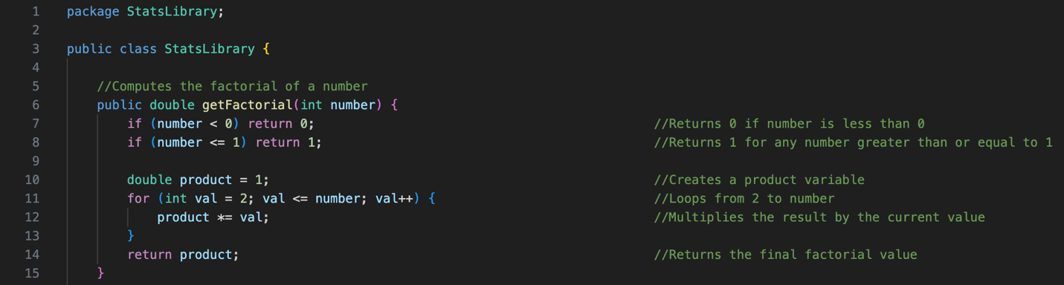

### Poissan

Two variables are calculated, the numerator and the denominator. Afterwords, it gives the division of the two.

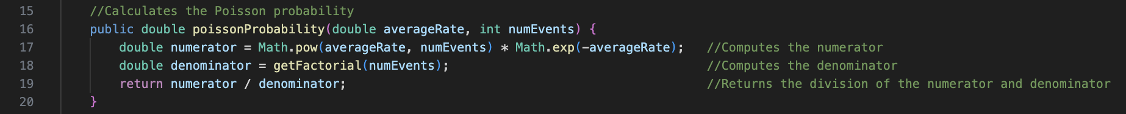

### Chebyshev

Multiples the standard deviation by the standard deviation. Then it returns the value of 1 minus (1 divided by the standard deviation).

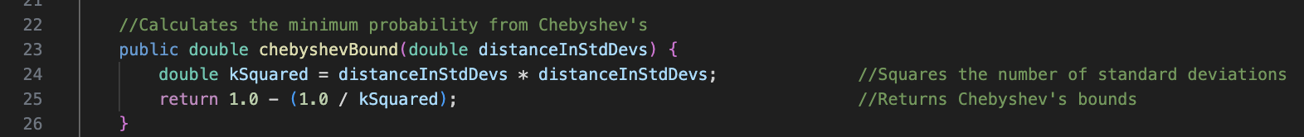

### Uniform Distribution

Gives the parameters of value, start, and end values. Checks if the values are inside the range given. If they are, finds the midpoint or average. Also calculates the spread. Afterwords, gives the uniform distribution by subtracting the end and start values and dividing them by 1.

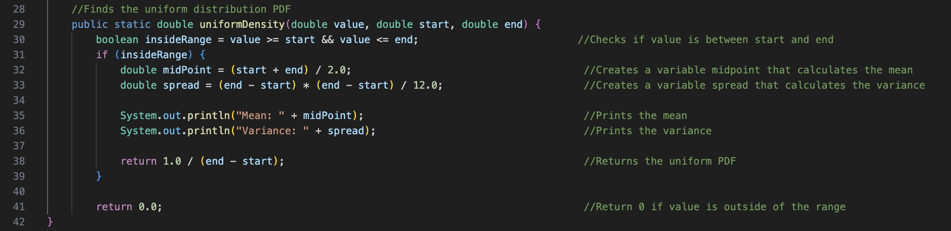

### Normal Distribution

Takes the parameters of the input, average, and the standard deviation values. Afterwords calculates the difference with the input and average. Finds the exponents powers and uses the scale factor to multiply that by the exponent found.

